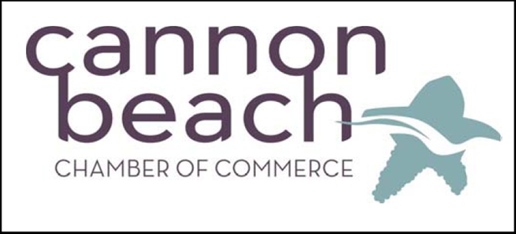
Participating Members

Duebers, Shorelines NW
The Wine Shack
Basketcase
Dena’s Shop on the Corner
Purple Moon
Sweet Basil’s Café
Puppy Love by the Sea
Pizza a Fetta
Bella Espresso
Bruce’s Candy Kitchen
Sharon Amber Jewelry
Maggie and Henry
Primary Elements Gallery
Bronze Coast Gallery
Cannon Beach Treasure Co
Dogs Allowed Cannon Beach
La Luna Loca
Jeffrey Hull Gallery
Morris Fireside Restaurant
Cannon Beach Leather Company
Voyages Toy Shop
Fultanos Oro
Seasons Café
Chillin at the Beach
Crepe Neptune
George Vetter Gallery
Organic Boutique
Oil and Vinegar Bar
Fruffels
Found
Cannon Beach Surf
Copies and Fax
Cannon Beach Liquor
Icefire Glassworks
Cannon Beach Yoga Arts

