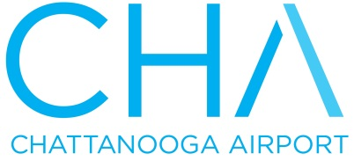

1001 Airport Rd. – Ste. 14 • Chattanooga, TN 37421 • Tel. (423) 855-2200
www.chattairport.com

Quick Facts Sheet

---Reach over 1000 destinations via nonstop or one-stop service
---Avoid the hassles! No long lines and only a 15 minute drive to downtown
---Over 10,000 weekly seats

Nonstop service to:
- Atlanta - DFW – Dallas/Ft. Worth
- Charlotte - Chicago – O’Hare
- Detroit - Orlando - Sanford
- Tampa / St. Pete - Washington DC – Reagan National
- NYC – Newark & LaGuardia

Flight Information by Airline

AIRLINE NONSTOP TO DEPARTURES
Allegiant Orlando / Sanford 2 weekly departures * St. Pete / Clearwater 3 weekly departures *
American Chicago 2 daily departures **
Dallas 3 daily departures **
Charlotte 6 daily departures
Washington DC/Reagan 1 daily departure
Delta Atlanta 10 daily departures
Detroit 2 daily departures
NYC – LaGuardia 1 daily departure ***
United Chicago-O’Hare 2 daily departures
NYC - Newark 2 daily departures
(1 departure on Sundays)

*Allegiant schedules change seasonally. The third weekly departure to St. Pete starts in June 2018
** American starts 2nd daily departure to Chicago and 3rd daily departure to DFW in June 2018.
*** Delta starts daily departure to NYC-LGA on July 9, 2018.

Thank you for considering Chattanooga for your convention – we are thrilled that
you may be joining us. With four airlines serving nine nonstop destinations and
thousands of worldwide connections, the Chattanooga Airport can meet your travel
needs. Have a wonderful time in Chattanooga!

CONTACT: Chattanooga Metropolitan Airport Authority
(423) 855-2200 updated April 2018

