Extranet Instructions
Updating Amenities

http://extranet.denver.simpleviewcrm.com

Viewing Your Amenities
Amenities are viewed and managed from the accounts section of the extranet. To find amenities from the home screen click Profile -> Accounts from the left main navigation. From the Accounts page click the down arrow under the actions column to find the Manage Amenities button.

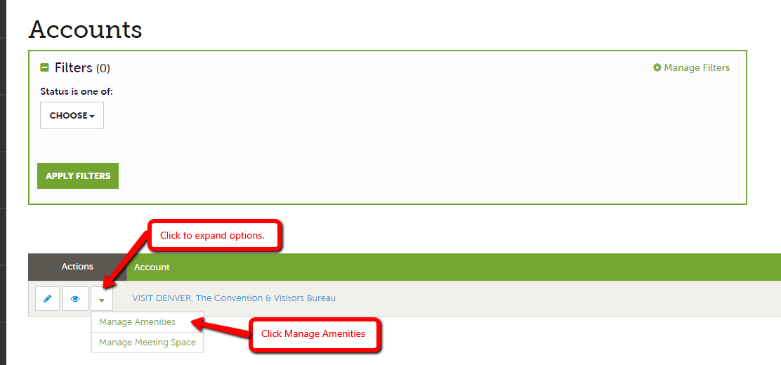

Amenities
You will see a variety amenity groups within the amenities section such as accommodations, restaurant, meeting facilities etc…

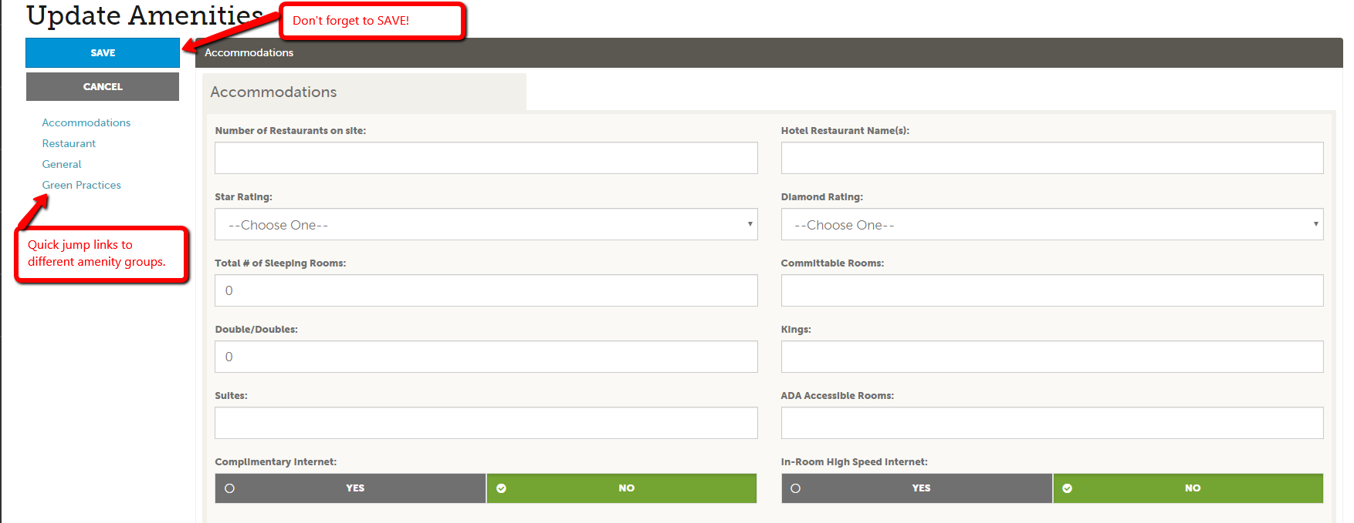

Click into any of the amenity fields to start making changes. Be sure to hit save once you are finished.

Note
It is very important to keep your amenity information up to date as this information displays on the website. This information is also used by CVB staff when searching for venues that can accommodate groups of various sizes.
Attraction providers should be sure to update the fields “Hours of Operation” and “Ticket Prices”

