Extranet Instructions
Updating Special Offers (Coupons)

http://extranet.denver.simpleviewcrm.com

Viewing Your Special Offers (coupons)
To access the Special Offers section click the Collateral link from the left main navigation and select Special Offers.
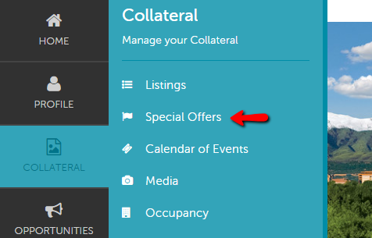

Special Offers:
- Once inside the special offers page you can edit any existing offers or create a new one.
- Any past offers you have posted will also be listed in this screen
  - You can filter them so that only the pending coupons show
  - They can also be sorted by column/feature

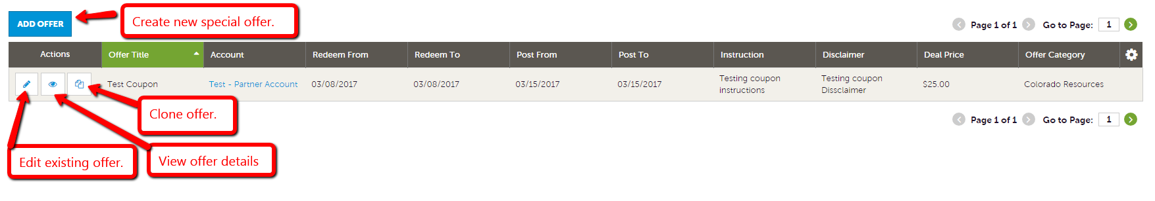

- To add a new coupon, click on the “Add New Coupon” button
- Complete the fields on the form
  - Offer Title
  - Offer Link (if you have a page on your site that specifically details this offer)
  - Offer Text – Description/details of the offer – include benefits, price, restriction dates and how to redeem offer if applicable
  - The “Redeem From” & “Redeem To” Dates – these will print on the coupon as dates which the coupon is valid (e.g. expiration date)
  - The “Post To” and Post From” Dates – determined by you, your coupon will only show up on the website during these dates – it will automatically be removed on the day after the “Post To” date
  - Select a category for your offer.
  - Select the listing this offer should be attached to.
  - Click “Save” to submit the coupon to the CVB for approval.

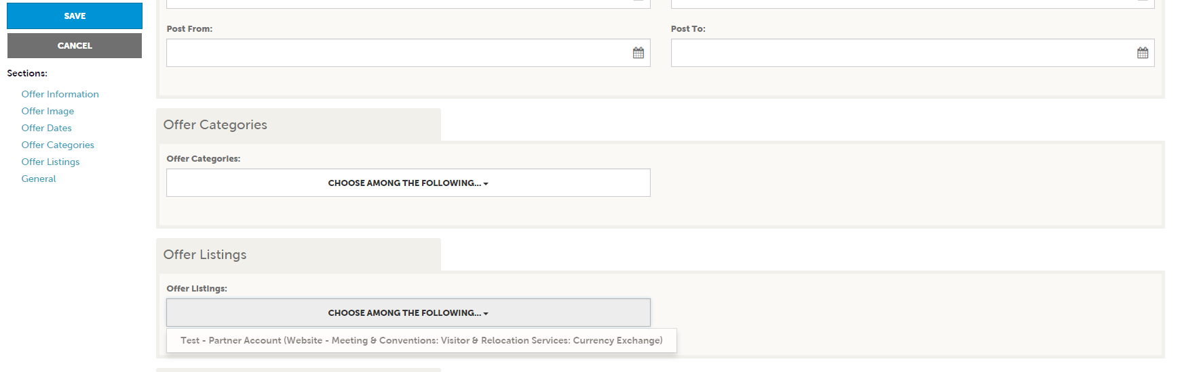

- Upon approval, your offer will appear on your individual listing, as well as on a page listing all Coupons/Special Offers that our members have available
- To edit the coupon, you just need to click on the pencil link to the left of your coupon, and make the desired changes

