Extranet Instructions
Updating Media

http://extranet.denver.simpleviewcrm.com

Viewing Your Media
Media are found under the collateral section of the extranet. To view your media click the Collateral link from the left main navigation and then click Media.
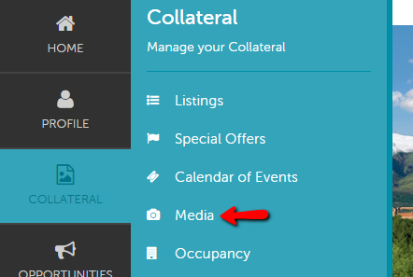

To add new media
- Click on the “Add New Media” button on the left hand side of the screen.

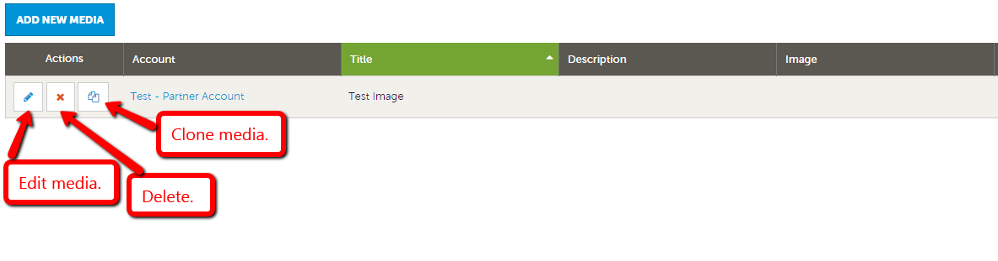

- For your main thumbnail, choose “logo” for type; for photo gallery images choose “image” for type
- Enter the Title of the photo you are uploading
- Browse to find the file on your computer
- Click the box to the left of the listings you would like the image to appear on (Publication Guide listings do not apply)
- Click save to save your image to your account

To add a new YouTube video:
- Click on the “Add New Media” button.
- In the “Type” drop down field select YouTube.
- Enter the Title of the video you are uploading
- Enter the YouTube URL for your video without the “http://”. For example: Enter only www.youtube.com/watch?v=UY435zgRxHo
- Select which listing this video should be attached to. (Publication Guide listings do not apply)
- Click save to save your YouTube video to your account

