CRM Instructions
Updating Account Record

http://extranet.denver.simpleviewcrm.com

Viewing Your Member Record
Your partner account information is located within the profile section of the extranet. To view or edit your account information click the Profile link from the main navigation and click Accounts.

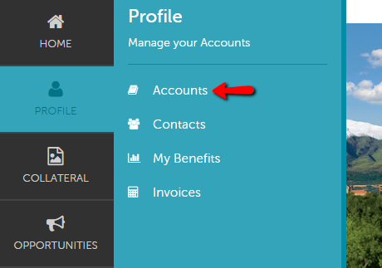

Accounts
After you click the Profile icon and then Accounts, you will be presented with your account name and various action you can perform. If you see multiple account names, this is due to your property being associated with another property. The pencil icon will allow you to edit your property information. By clicking the eyeball icon, you can view your property information. The down arrow icon will allow you to view and edit your amenity and meeting space information.

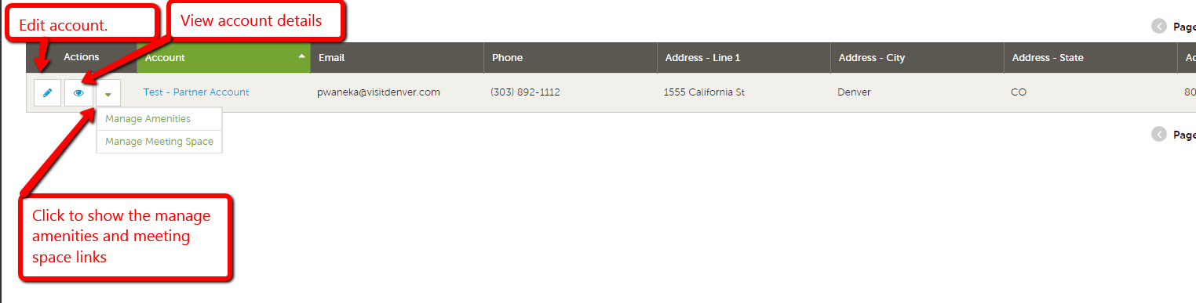

Editing Account Information
- Click the pencil icon located to the left of the account you wish to edit.
- Adjust any of the fields you need.
  - Note: Account name cannot be changed. If you need to adjust your account name please contact VISIT DENVER.
  - Address fields can be edited by click the pencil icon located above each address.
- Click the Save button when finished.

