Extranet Instructions
Service Requests

http://extranet.denver.simpleviewcrm.com

Reviewing Service Requests:
- Once you are logged in, click on the “Opportunities” link in the left navigation and select “Service Requests”.
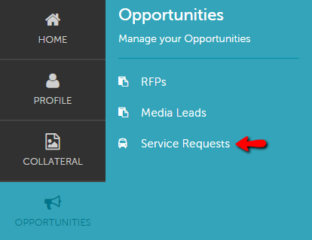
- You will be able to view all Service Requests that your property was included in.
  - Groups (Meeting, Tour, Media,)
- You are able to sort your list of service requests by using the filter section or by clicking on any of the column headers (i.e. Service Request, Contact, etc)

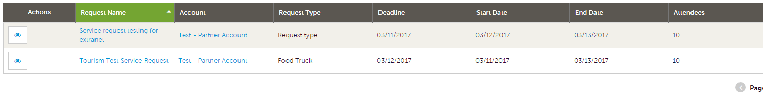
Viewing Service requests:
- Click on the Eye Icon or Title to open and view.

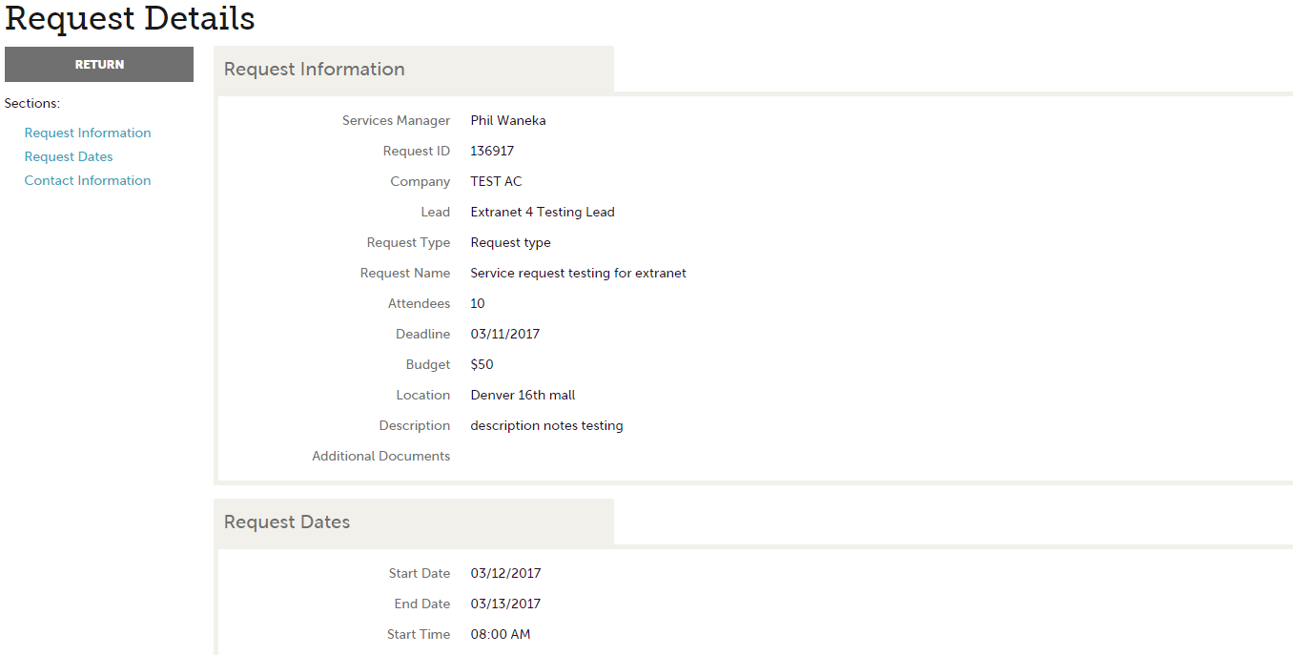

- You will notice the Contact information is available on the detail screen, use the email address provided to send your response directly to the client.

