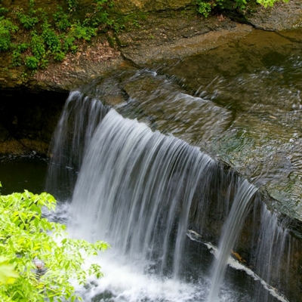
Waterfalls
Discover Dublin’s hidden gems.
- Waterfalls
- Hayden Run Falls
- Wedgewood Hills Falls
- Glick Park and Overlook
Details: https://www.visitdublinohio.com/blog/post/dublin-ohio-waterfall-tour/

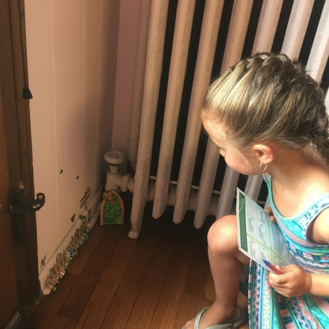
Irish Fairy Door Trail
Discover the unique shops of Downtown Dublin while searching for tiny, Irish fairy doors. Find the name of each door’s resident fairy and redeem your free t-shirt.
- In partnership with the Irish Fairy Door Company out of Dublin, Ireland
- Over 2,300 completed Trail Guides
Details: https://www.visitdublinohio.com/things-to-do/fairy-door-trail/
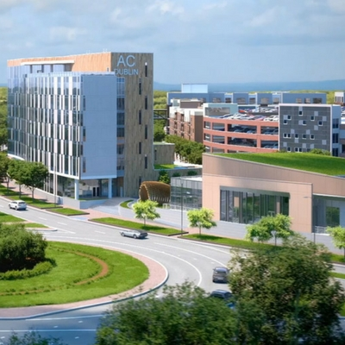
Downtown Dublin
Downtown Dublin is the perfect mix of historic charm and modern vibrancy.
- Bridge Park
- Historic Dublin
- Walkable with Pedestrian Bridge and Riverside Park
- AC Marriott and The Exchange
Details: https://www.visitdublinohio.com/things-to-do/downtown-dublin/

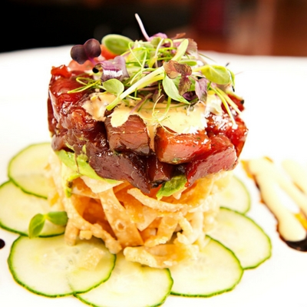
Dining
Dublin is quickly transforming into a dining destination made up of long standing local favorites and unique new concepts to appease any appetite.
- Local Favorites
- New Restaurants
- Cameron Mitchell Invests in Dublin
- Two Brother Bar + Kitchen changes hotel dining
- Irish Fare
Details: https://www.visitdublinohio.com/restaurants/
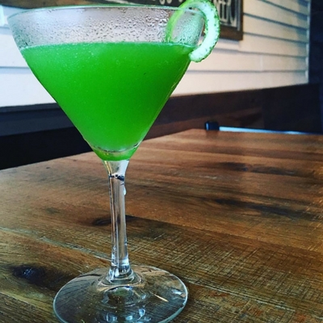
Celtic Cocktail Trail
Coming in 2018 is Dublin’s newest trail experience, the Celtic Cocktail Trail. Sip Irish-inspired cocktails while enjoying Dublin’s unique restaurants. Pick up your passport and collect six stamps to redeem a prize.
Details to come.

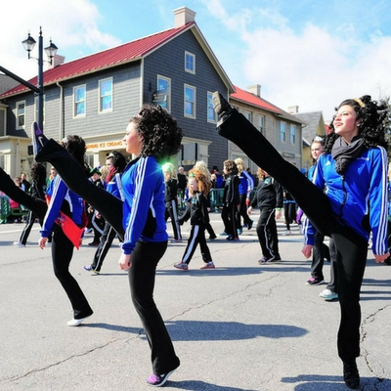
Irish is an Attitude
Dublin is known for its connection to all things Irish! From our name, to our events, you’ll find some Irish inspiration while in Dublin, Ohio.
- Dublin Irish Festival
- St. Patrick’s Day
- Irish Approved Businesses
- ShamROCKin’ Sessions
Details: www.VisitDublinOhio.com

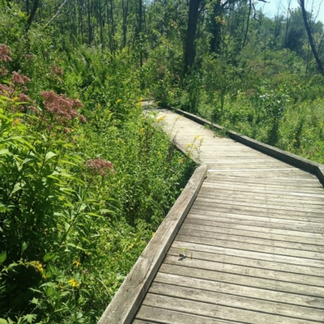
Outdoors
No destination does “green” like Dublin. Explore the outdoors and discover parks, public art and picturesque waterfalls.
- 60+ Developed Parks
- 100+ Miles of Bike Trails
- Over 70 Pieces of Public Art
- Scioto River Access for Kayaking, Fishing, SUP
Details: https://www.visitdublinohio.com/things-to-do/sports-parks-and-outdoors/

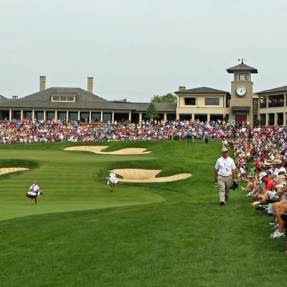
Events
Dublin is home to world-class events.
- the Memorial Tournament
- Dublin Irish Festival
- Frog Jump & Festival
- Independence Day
Details: https://www.visitdublinohio.com/events/

