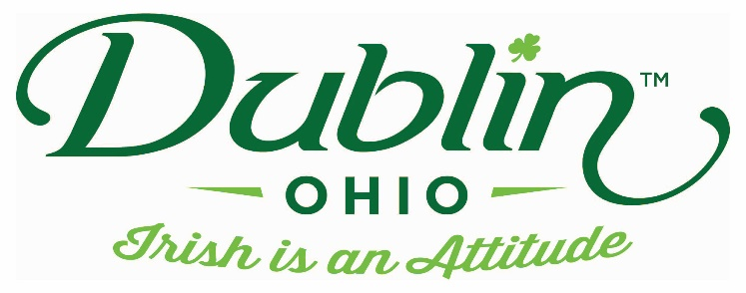

Experience Name: Ancient Saints of Ireland
Type of Experience: Storytelling
Length of Experience: 1 hour
Min. group number: No min. Max. group number: No Max
Cost: $150 for up to 25 ppls, then $2 pp after 25
Driver comp: No Escort Comp: Yes
Takeaway: St. Brigid’s Cross
Details: In Downpatrick, three saints and one grave to fill: Patrick, Brigid and Columcille. Two were former slaves, all were miracle workers and one was even master of the Loch Ness Monster – St. Patrick, St. Bigid and St. Columba (Columcille), the patron saints of Ireland. Come hear author Cindy Thomson tell stories about their lives and legends – and learn how to weave a St. Brigid’s Cross to take home. Cindy is the author of Celtic Wisdom, Treasures From Ireland and Bride of Ireland, a Historical Novel.
Parking Information: Depends upon location of Storytelling
Booking Information:
Contact – Cindy Thomson
Phone – (614) 354-3904 (cell)
Email – cindy@cindyswriting.com

Best “Day Of” Contact number
Phone – (614) 354-3904 (cell)

