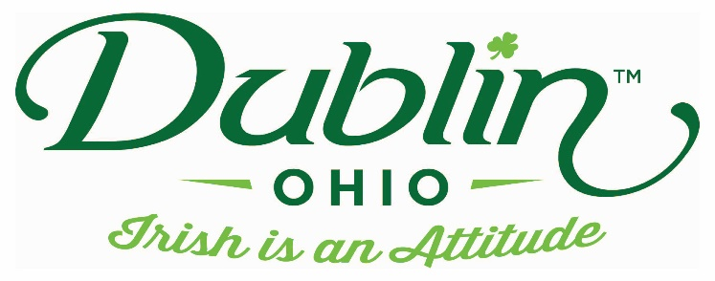

Experience Name: Bogey Bar & Grill
Type of Experience: Lunch or Dinner
Length of Experience: 1 – 2 Hours
Min. group number: 10 Max. group number: 50
Cost: $20 per person
Driver comp: No Escort Comp: No
Takeaway: N/A
Details: Lunch for bus tours include, per person: 1 Reuben Roll appetizer, choice of Fish & Chips or Chicken Caesar Wrap, both with French fries, a fountain drink and dessert, either mini cheesecakes or brownie bites. Tax and gratuity is included at the $20 per person price. Alcohol is available and can be purchased separately.
Parking Information: We have 2 large parking lots, one in the front of the building and the other around the back, both can accommodate buses of any size.
Booking Information:
Contact – Rebecca Brown or Mark Dombek, GM
Phone – (614) 581-0077 and 614-766-1900
Email – party@bogeyinn.com

Best “Day Of” Contact number
Phone – (614) 581-0077

