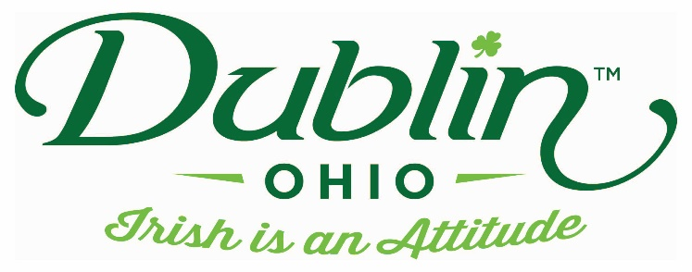

Experience Name: Charming Irish Jewels
Type of Experience: Hands-on
Length of Experience: 60 minutes for earrings / 90 minutes for bracelets
Min. group number: none Max. group number: 45
Cost: $5pp earring / $15pp bracelet
Driver comp: yes Escort Comp: yes
Takeaway: earrings or bracelet
Details: Explore the wonderful world of bead making in Dublin’s only bead shop. Participants will be taught how to design and make a pair of earrings or a bracelet with beads from our Irish section.
Parking Information: Buses can drop off guests and park in the rear of the building
Booking Information:
Contact – Cathie Reichert
Phone – (614) 573-6452
Email – cathie@1stopbeadshop.com

Best “Day Of” Contact number
Phone – (614) 573-6452 (store)
(614) 582-5161 (owner cell)

