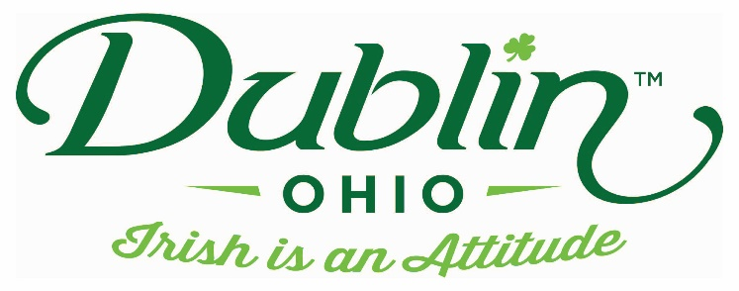

Experience Name: Irish Wake
Type of Experience: Storytelling
Length of Experience: 45 minutes
Min. group number: No min. Max. group number: Limited by size of room
Cost: $75
Driver comp: Yes Escort Comp: Yes
Takeaway: Paper Handout (Book purchase opportunity)
Details: In previous centuries, the Irish Wake was a multi-day way for the whole community to come together and celebrate the life of one who had passed. We will look at many of the customs associated with the wake and how it came to have a wild reputation (think of it as a going away party)
Parking Information: Depends upon location of Storytelling
Booking Information:
Contact – Cathy Jo Smith
Phone – (614) 370-2625 (cell)
Email – CathyJoSmith@yahoo.com

Best “Day Of” Contact number
Phone – (614) 370-2625 (cell)

