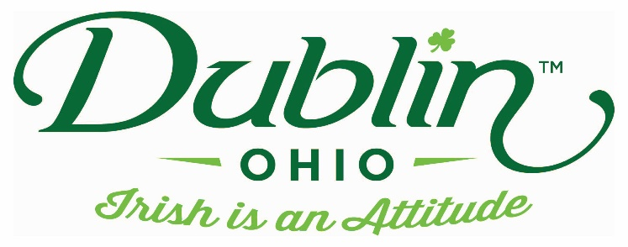

Experience Name: Shamrock String Art
Type of Experience: Hands-On
Length of Experience: 60 minutes
Min. group number: 5 Max. group number: 45
Cost: $15 un-nailed / $20 pre-nailed
Driver comp: See Escort Escort Comp: 1 free comp per 10 guests
Takeaway: Each person will leave with their own handmade string art creation
Details: Our string art workshop is hands-down the most popular workshop we offer. Each person will leave with a completely original piece. The event is offered in two different ways. Your group can choose to just do the stringing portion of the event (boards come pre-nailed) or they can choose to do the full project starting with the putting the nails in the board themselves. These options are great for groups with varying skill levels or time restrictions.
Parking Information: Motorcoaches can drop off across the street at the Dublin library. Parking is just further ahead in a large parking lot.
Booking Information:
Contact – Jessica Foust
Phone – (614) 376-4531
Email – creativelystated@gmail.com (preferred)

Best “Day Of” Contact number
Phone – (614) 376-4531

