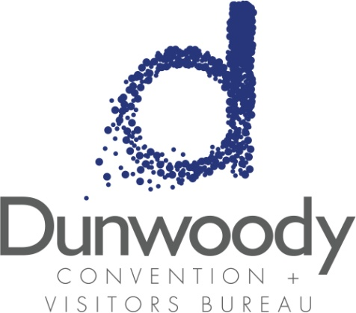

First Quarter Board Meeting
January 26, 2017
11:30 a.m. – 1:00 p.m.
Meeting Agenda:

- Meeting Called to Order

- Minutes
- October 20 Board Meeting

- 2017 Board and Officer Nominations

- Committee Reports
  - Executive
  - Personnel
  - Finance

- City of Dunwoody Report Michael Starling

- Executive Director’s Report Katie Williams

- Old Business
  - 2017 CVBD Annual Meeting
  - Civic Projects Policy

- New Business
  - 2017 Business Plan Presentation

- Adjourn

