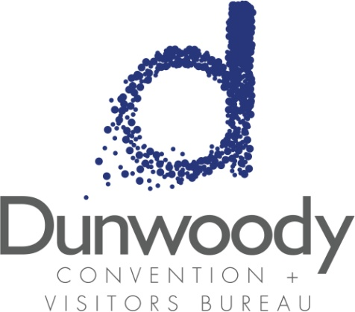

First Quarter Board Meeting
March 29, 2018
11:30 a.m. – 1:00 p.m.
Meeting Agenda:

- Meeting Called to Order

- Minutes
- October 12, 2017
- December 12, 2017

- Committee Reports
  - Executive
  - Personnel
  - Finance

- PCID Update Ann Hanlon, Executive Director, PCID

- Executive Director’s Report Katie Williams

  - Marketing Report Kimberly Franz

- Old Business
  - 2018 Nominating Committee – Open Board Seat

- New Business
- Knowland Insight Proposal
- 2018 Research Study

- Adjourn

