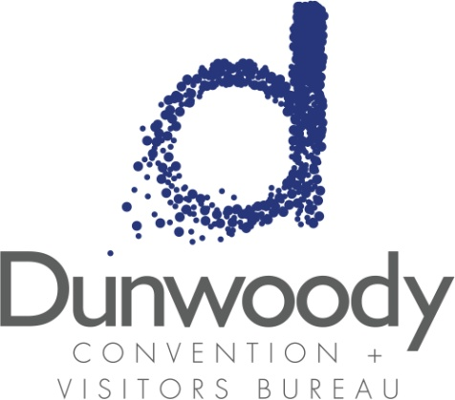

Special Called Board Meeting
March 30, 2017
11:30 a.m. – 1:00 p.m.
Meeting Agenda:

- Meeting Called to Order

- Minutes
- January 26 Board Meeting

- Committee Reports
  - Executive
  - Personnel
  - Finance

- City of Dunwoody Report Michael Starling

- Executive Director’s Report Katie Williams

- Old Business
  - 2017 CVBD Annual Meeting

- New Business

- Adjourn

