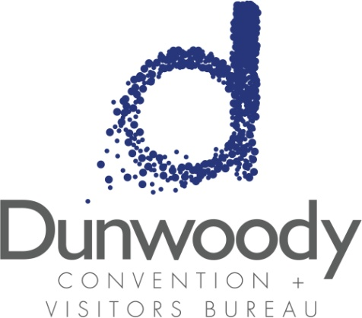

Second Quarter Board Meeting
May 5, 2016
11:30 a.m. – 1:00 p.m.
Meeting Agenda:

- Meeting Called to Order

- Minutes
- March 5, 2016 Board Meeting

- Committee Reports
  - Executive Michael Bryan
  - Personnel Nancy Musselwhite
  - Finance Bill Grant

- Director’s Report Katie Williams

- Old Business

- New Business
  - Q1 Financials Bill Grant
  - City of Dunwoody Update Michael Starling
  - By Laws Revisions
  - Internal Controls Policy Revisions

- Adjourn

