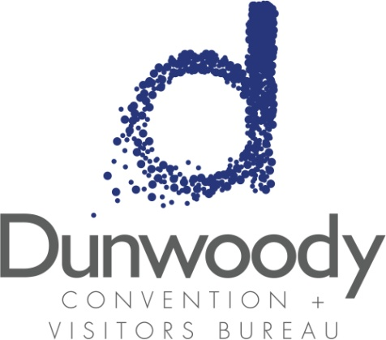

Fourth Quarter Board Meeting
October 12, 2017
11:30 a.m. – 1:00 p.m.
Meeting Agenda:

- Meeting Called to Order

- Minutes
- August 17, 2017

- Committee Reports
  - Executive
  - Personnel
  - Finance

- City of Dunwoody Report Michael Starling

- Executive Director’s Report Katie Williams

  - Marketing Report Kimberly Franz
  - Sales Report Steven Schumacher

- Old Business
  - CVBD Office Relocation Update
  - 2018 Nominating Committee

- New Business
- 2018 Budget Presentation
- 2017/2018 Meeting Schedule

- Adjourn

