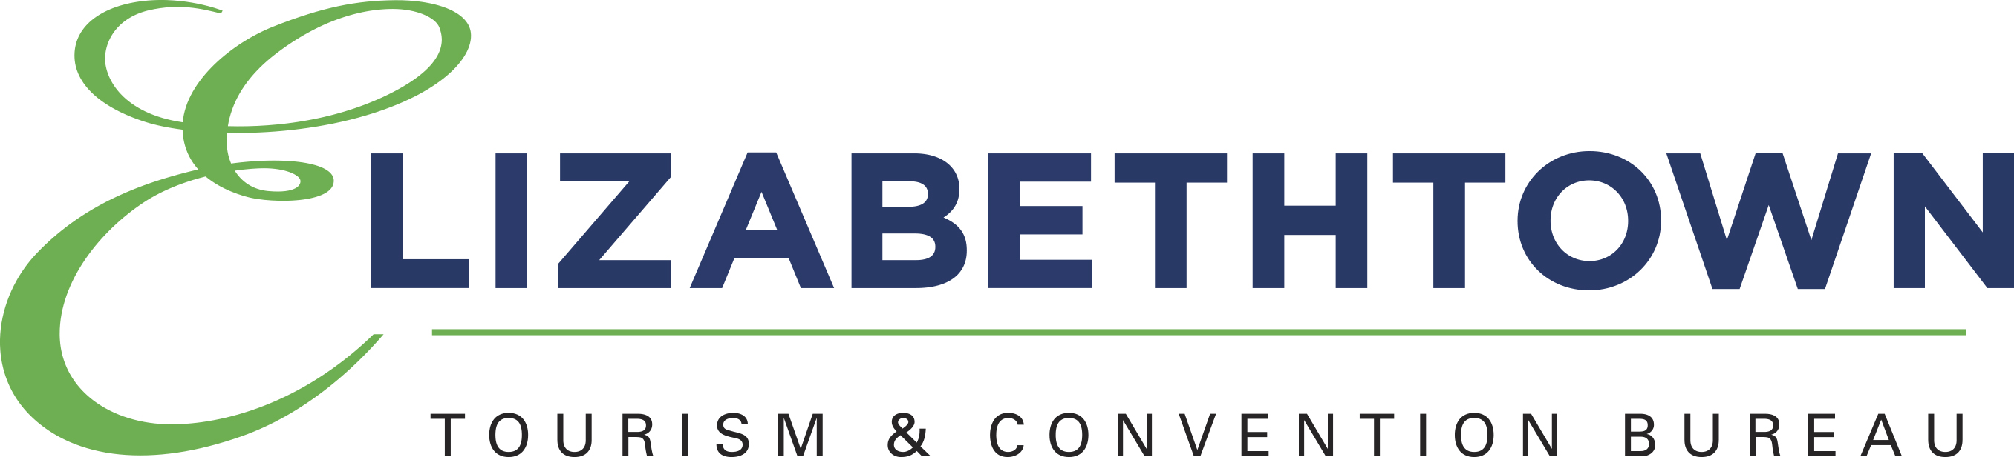
Post Event Report
(This report must be submitted within 45 business days
after the event date in order to receive the allotted funds.)

Name of event: ___________________________________________________________

Granted amount $ __________

Name of person submitting this information:

Telephone number:

E-Mail address:

Number of attendees:

Which hotels were utilized?

Which restaurants were utilized?

Please list every item purchased with ETCB funding. If funds were spent on advertising, please include photocopies of all print ads as well as audio for radio/TV ads. If any promotional items were produced for the event, please present the item or a picture of the item with ETCB logo visible.

Attach photocopies of cancelled checks and matching invoices for every item purchased using ETCB funds. Post event forms will NOT be accepted without them.

NOTE: Funds must be spent on pre-approved purposes to receive reimbursement. The ETCB reserves the right to withdrawal all or partial reimbursement if funds are not used for pre-approved purchases. If funds are used on event fliers, newspaper and magazine advertising they must carry the ETCB logo and copies of each must be submitted with the report. All radio and television advertising mentioning the ETCB as a contributor must also be included. All promotional items produced for the event must carry the ETCB logo.

Once the post-event report is submitted and reviewed, a reimbursement check will be given at the next official ETCB Commission meeting. A representative of your event must attend the meeting in order to have a promotional photograph taken of the check presentation.

