For immediate release: | 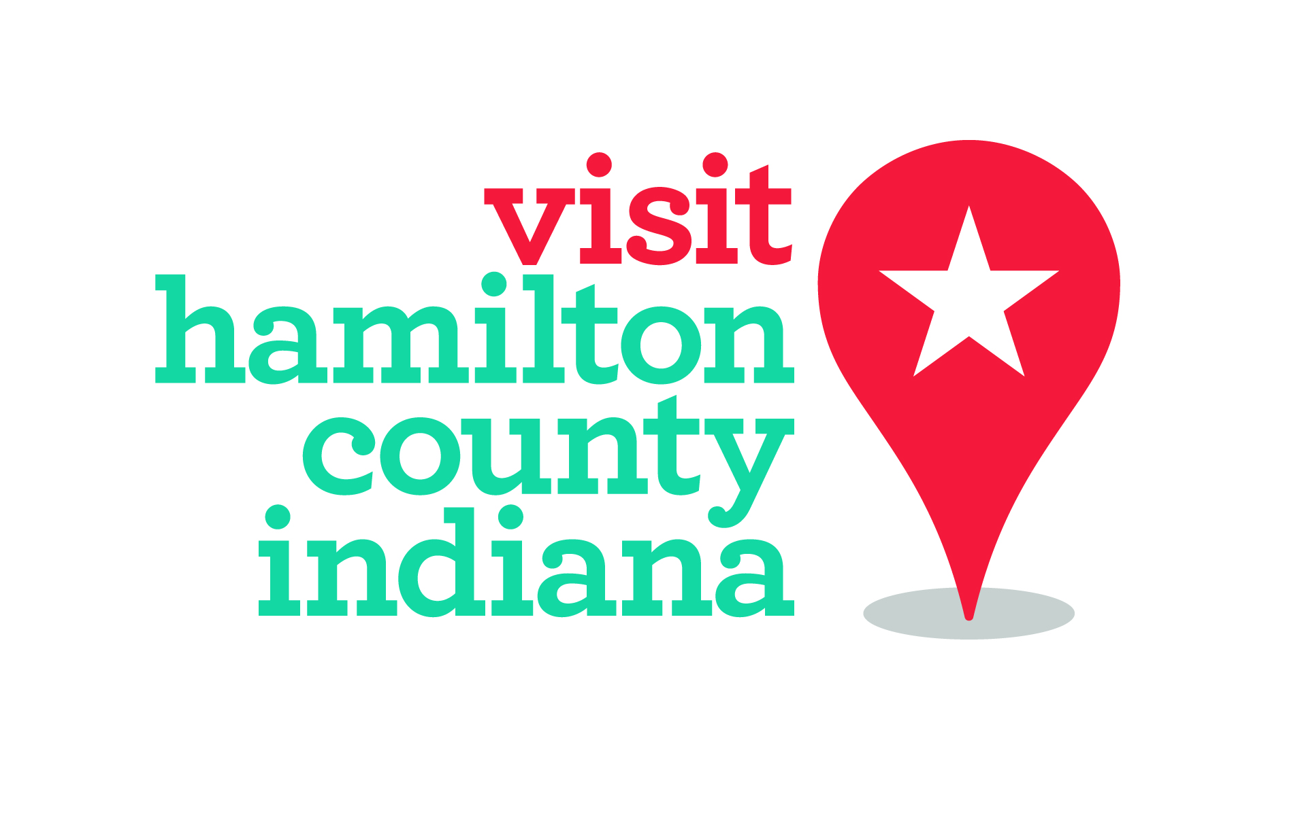
Dec. 21, 2017
Whitney Riggs
wriggs@hamiltoncountytourism.com
317-660-4046/812-430-7320
Visitor Spending in Hamilton County Continues to Grow
Rockport Analytics found a 9 percent increase from 2015 to 2016
Hamilton County, Ind. – The annual “tourism report card” for 2016 was released, and once again Hamilton County made the honor roll. The community’s report card mirrors county hotel data that shows consistent growth in room sales, which influences other areas in the hospitality sector.
The recently released annual Rockport Analytics study by the Indiana Office of Tourism Development shows visitor spending increased 9.3 percent in the county from the previous year (adjusted). In comparison, the Indianapolis Metropolitan Statistical Area (MSA) as a whole grew 6.1 percent and Indiana grew 5.7 percent in the same period.
Visitors to Hamilton County in 2016 spent $738.2 million in the region, with 90 percent of that spending staying in the county and the rest “leaking” to the region. All Central Indiana counties see spending leakage as communities can generate peak periods of business well beyond their capacity.
In total, it reflects more than $50 million in spending growth between 2015 and 2016 – in just one year.
The growth was consistent across all hospitality sectors. Hotels led the way with 9.4 percent in growth, fueled by more hotel rooms available and sold in the market, as well as a higher average daily rate due to high demand.
The economic impact of tourism overall in the county, less leakage, grew by 7.8 percent. Overall, jobs directly attributed to tourism visitation grew 7 percent to 11,307.
Tourism in Hamilton County generated $105.4 million in state and local taxes. Of that total, tourism accounted for $35 million in property taxes generated.
“Hamilton County works hard to invest and improve its communities,” said Brenda Myers, CEO/President of Hamilton County Tourism. “This data shows just how well that investment is paying off.”

