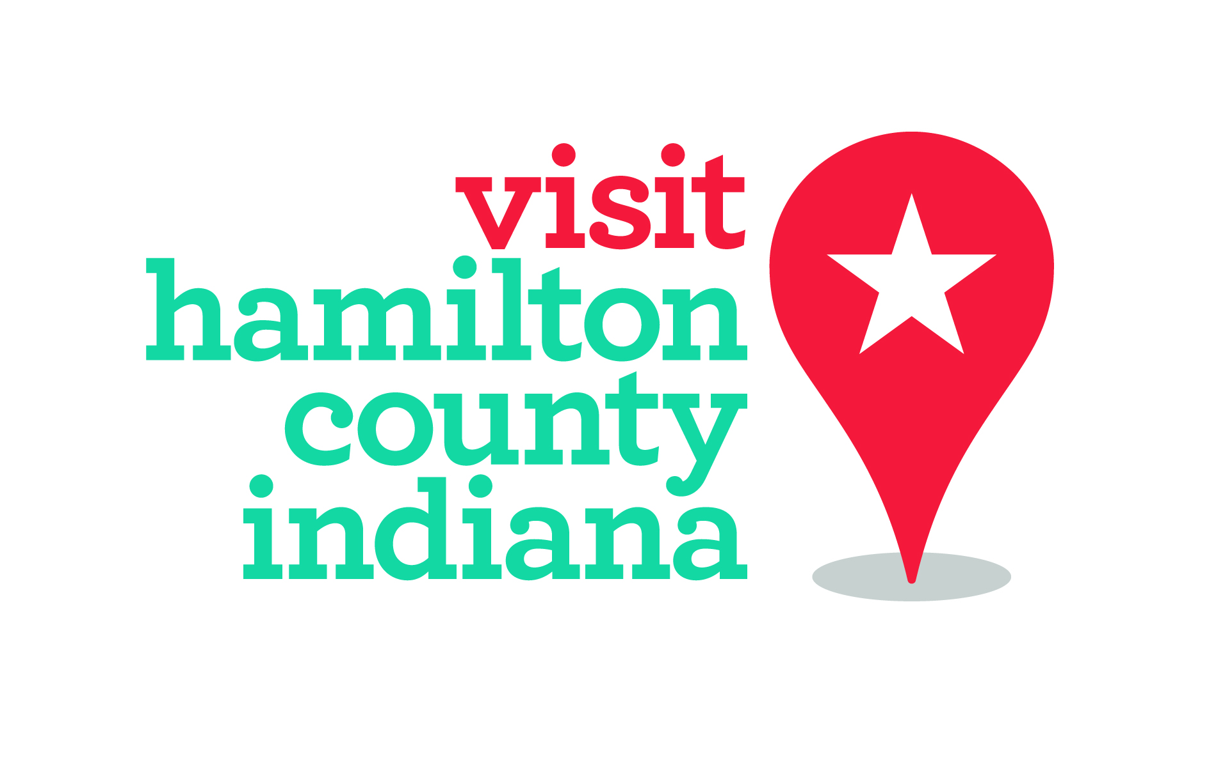

For immediate release:
March 13, 2018
Contact: Whitney Riggs
wriggs@hamiltoncountytourism.com
812-430-7320
Tourism Gives invests $100,000 in community organizations
HCT program provides funding for tourism-focused projects
Hamilton County, Ind. – A Hamilton County Tourism Inc. program will grant more than $100,000 to community and sports-related organizations this year. Local nonprofits, downtown and arts development organizations and area festivals are just a few of the more than two dozen fund recipients.

Tourism Gives, created by Hamilton County Tourism in 2016, provides operating cash to tourism-focused organizations, events and festivals using lodging tax funds to support items that boost visitor interest in the area. Grant amounts are based on local tourism impact.

“These grant programs are designed to support nonprofit cultural, arts and sports organizations as they provide great programming for both residents and visitors,” said Brenda Myers, president and CEO of Hamilton County Tourism. “They contribute to our quality of place in a significant way and provide for a quality visitor experience.”

Logan Street Sanctuary in Noblesville is one of this year’s 47 grant recipients. The nonprofit relies on volunteers to assist with annual events like the Noblesville Interdisciplinary Creativity Expo, Second Saturday Songwriters Showcase Series and the publication of The Polk Street Review.

“We operate out of a historic building at 1274 Logan Street in Noblesville’s Cultural Arts District, and grants that support and encourage community development are crucial to small organizations like ours,” said Alys Caviness-Gober, secretary of Logan Street Sanctuary.

Conner Prairie in Fishers is another grant recipient supported by the Tourism Gives program. Richard Thrapp, museum board member, said the grant funding expands the museum’s capacity to innovate the daily guest experience. Annually, the museum welcomes tens of thousands of visitors to the area to experience its programming.

Hamilton County Sports Authority, a division of Hamilton County Tourism, also awarded $17,000 in local sports development grants to organizations throughout the county. This is in addition to supporting local sports organizations with business development through sales initiatives and event bidding support.

“Hamilton County has so many great sports venues and organizations,” said John Towle, HCSA sports development manager. “This is one way we can support event and tournament growth while providing technical assistance.”

Other 2018 projects supported by Hamilton County Tourism include the underwriting of Nickel Plate Arts Inc. on the eastern half of the county, involvement as the co-coordinator for the upcoming White River Regional Master Plan with Marion County/Indianapolis and assistance with an upcoming study of the county’s parks system. HCT will also sponsor bicycle sharing stations in Carmel, Noblesville and Westfield this year.

Since 2006, Hamilton County Tourism has invested $7.5 million into the community. To see a full list of this year’s grant recipients, go to www.visithamiltoncounty.com/industry and click on “What We Do.” Information about Tourism Gives, including guidelines, can be found there.

Hamilton County Tourism Inc. is a nonprofit destination management organization that promotes tourism growth through strategic marketing, hospitality and development initiatives providing hospitality to more than four million visitors to Hamilton County, Indiana, each year.

