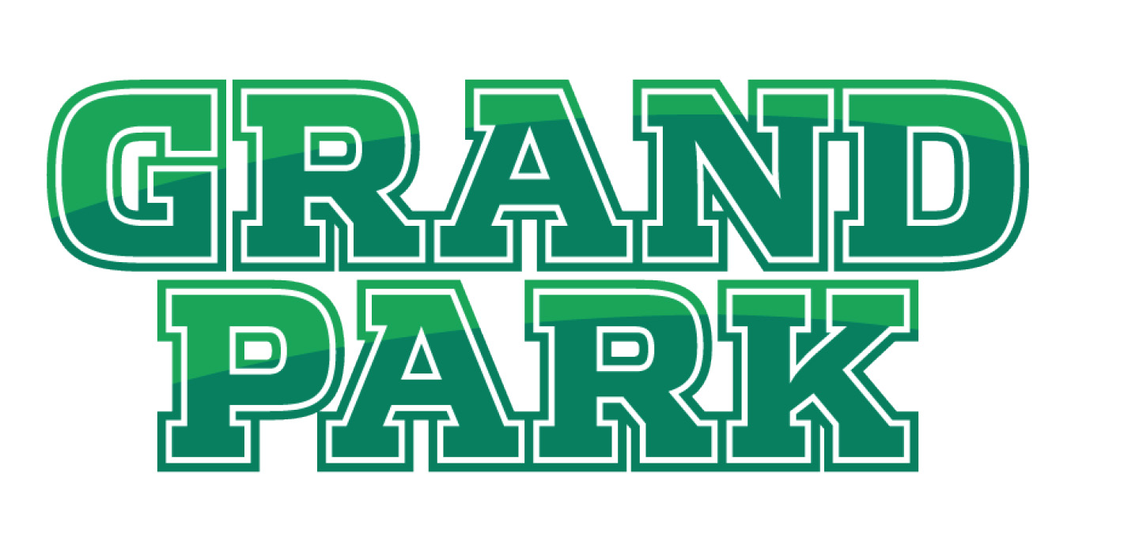

For Immediate Release

April 24, 2017
Whitney Riggs
wriggs@hamiltoncountytourism.com
812-430-7320

Grand Park to host Midwest Nike Challenge
More than 350 NCAA Division I coaches expected

WESTFIELD, Ind. – The Midwest Nike Challenge will take place at Grand Park Sports Campus this weekend, making it the second year the event is held in Westfield.

The Midwest Nike Challenge is the second of the Elite Youth Basketball League’s four sessions in the regular season. Forty 17U teams will compete and showcase some of the nation’s best high school basketball athletes.

More than 350 NCAA Division I coaches from the top basketball programs across the country are expected to attend.

“My staff and I are thrilled to have the opportunity to host the Nike EYBL and are excited for the City of Westfield,” said Brandon Lafferman, president of Grand Park Fieldhouse. “The presence of the talented athletes and Division I College coaches in our facility will create a very electrifying atmosphere for basketball fans of all ages.”

Since its inception in 2010, Nike EYBL has developed young basketball talent by allowing top athletes from around the country to compete head-to-head. Four of the past five number one picks in the NBA Draft played in the EYBL; 13 players in this year’s NCAA National Championship game played in EYBL.

This weekend’s session will be held from 6:30 p.m. to 11 p.m. on April 28, 9:30 a.m. to 9:30 p.m. on April 29 and 8 a.m. to 12:30 p.m. on April 30. It is open to the public with admission of $10.

Spectator parking is available at Monon Trail Elementary School’s parking lot, located at 19400 Tomlinson Road in Westfield. A complimentary shuttle will be available to the Fieldhouse. See attached map.

If you are a member of the media, you must register for credentials: http://www.nikeeyb.com/media/. Media credentials will be required for the Fieldhouse parking. For more information, visit www.nikeeyb.com.

Nike Elite Youth Basketball
Nike Elite Youth Basketball is dedicated to developing athlete potential through superior skill instruction, honest evaluation and unprecedented exposure. EYB programs and events encourage and challenge the nation’s youth to be positive community leaders on and off the court.

Grand Park Sports Campus
Grand Park in Westfield, Indiana, is a 400-acre sports campus featuring 26 baseball and softball diamonds, 31 multipurpose fields for soccer, football and lacrosse. The Grand Park Events Center features three full-sized indoor soccer fields, a restaurant and administrative offices. The Grand Park Fieldhouse indoor basketball/volleyball facility opened last year.

Hamilton County Sports Authority
Hamilton County Sports Authority is a division of Hamilton County Tourism and provides many services, grants and assistance to make events a success. The organization can assist groups in many ways, including site selection, lodging and publicity.

