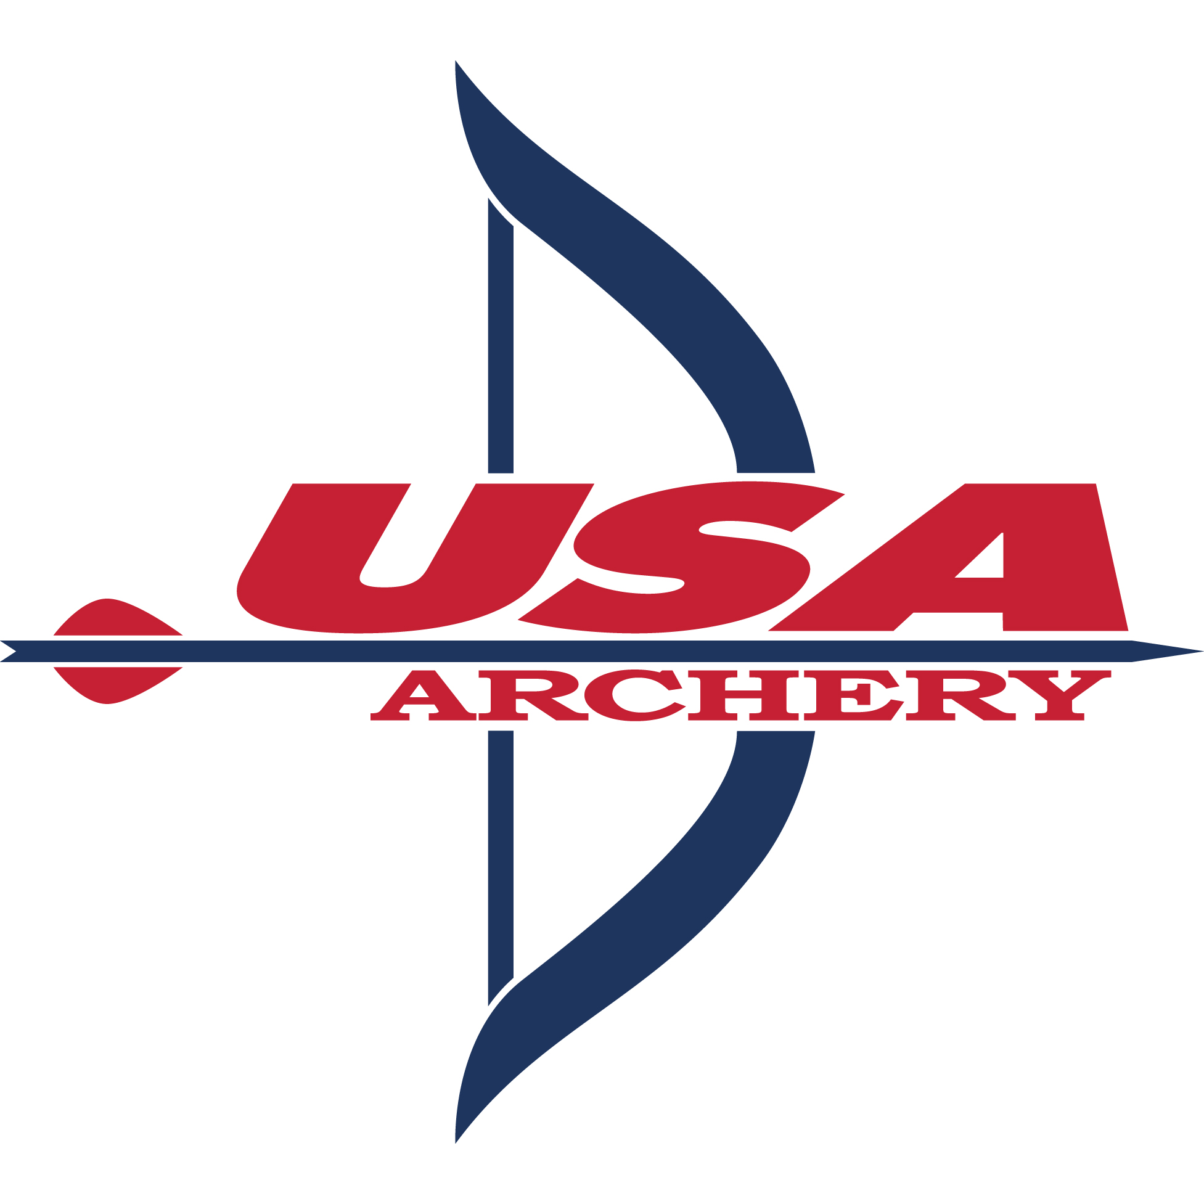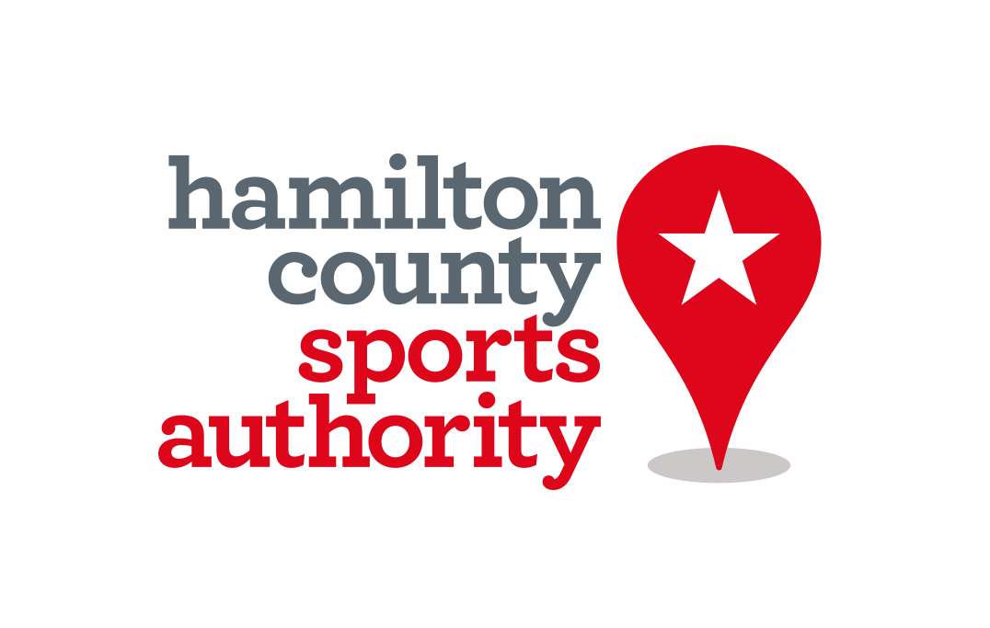

For Immediate Release
June 13, 2017
U.S. Archery championships coming to Hamilton County
More than 1,000 archers anticipated at Grand Park in August
Hamilton County, Ind. – The National Target Championships will be held at Grand Park Sports Campus in Westfield this summer. It’s anticipated that more than 1,000 archers, including Olympians, World Champions and youth athletes, will compete in the tournament from Aug. 2 -6.

Events will include the U.S. and Junior Olympic Archery Development (known as JOAD) National Target Championships, which are used for National Ranking for U.S. athletes and selection of the Nationals U.S. Archery Team.

These competitions feature qualifications where archers shoot 144 arrows for score. They are then ranked and compete in head-to-head elimination matches. U.S. Open Finals will be held Aug. 5, where the senior divisions will compete in the medal matches in a special finals venue.

“USA Archery is looking forward to bringing our Outdoor Nationals to Westfield, Indiana,” said USA Archery CEO Denise Parker. “The community support has been wonderful and we are thrilled to put on a great event for our athletes at Grand Park.”

USA Archery officials say the archers to watch out for include Leonardo DiCaprio look-alike and three-time Olympic medalist Brady Ellison, five-time Olympian Khatuna Lorig, Olympian Mackenzie Brown and World Champions Steve Anderson, Reo Wilde, Jamie Van Natta and the new faces breaking into the international scene.

The public and media are welcome to come out and enjoy the event. Times will be scheduled during the weekdays for participants to find their inner Katniss Everdeen and shoot a bow and arrow, win prizes and meet the athletes at the Try-Me field event.

“As the most anticipated national archery event of the year heads to Indiana, we welcome everyone to join us and cheer for our athletes in this exciting tournament,” Parker said.

For more information, visit here and follow USA Archery on Facebook, Twitter and Instagram. For media questions or credential requests, contact media@usarchery.org.

About USA Archery
USA Archery is the National Governing Body for the Olympic sport of archery. USA Archery selects and trains Olympic, Paralympic, World Championship, and World Cup teams, as well as developing archery at the grassroots level across the United States. For more information, visit http://www.usarchery.org.
Media Contact
Sarah Bernstein/Public Relations
sbernstein@usarchery.org
201.919.8050

About Hamilton County Sports Authority
Hamilton County Sports Authority is a division of Hamilton County Tourism and provides many services, grants and assistance to make events a success. The organization can assist groups in many ways, including site selection, lodging and publicity. Visit https://www.visithamiltoncounty.com/sports/.
Media Contact
Whitney Riggs/Communications Coordinator
wriggs@hamiltoncountytourism.com
812.430.7320

