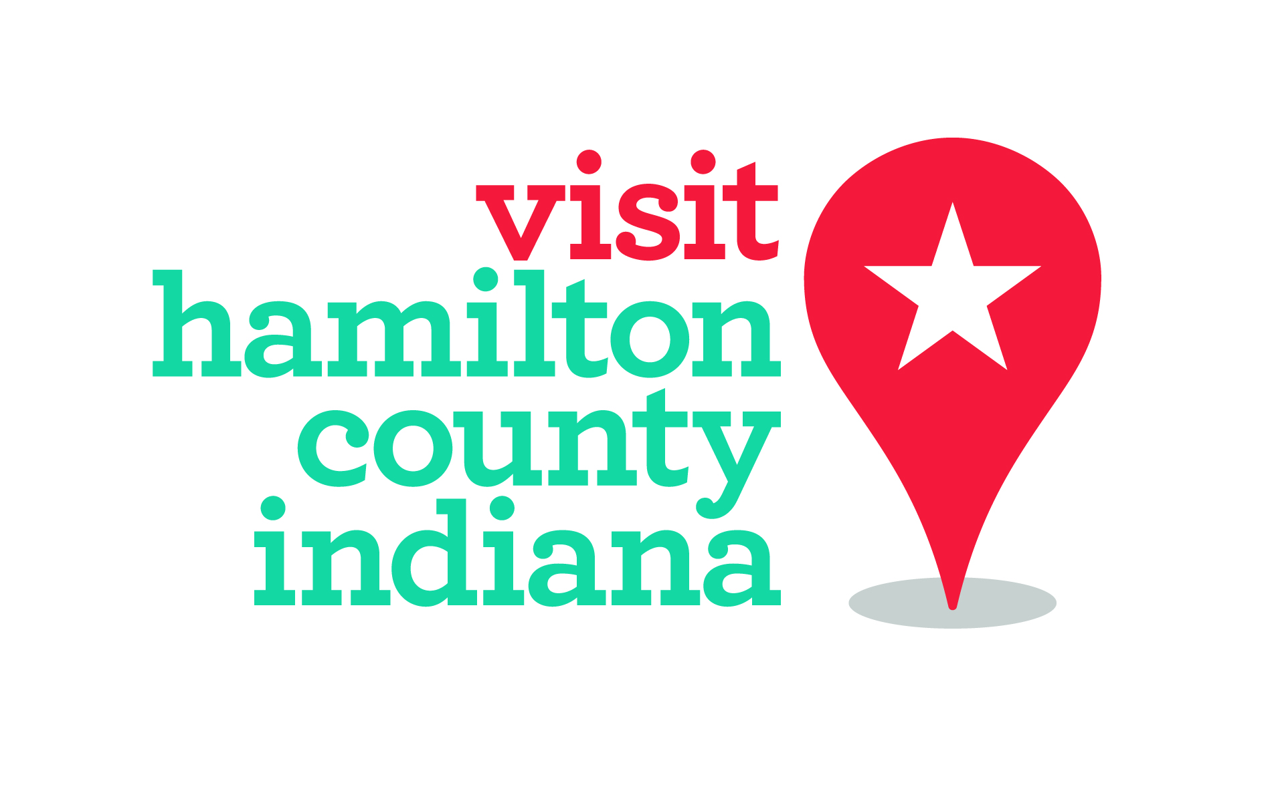

For immediate release:
April 27, 2018
Contact: Whitney Riggs
wriggs@hamiltoncountytourism.com
812-430-7320
Pedal Perks program returns during National Bike Month
Discounts offered to bicyclists who visit area attractions and businesses

Hamilton County, Ind. – The Pedal Perks program is back for its second year in Hamilton County with even more businesses offering deals to bicyclists. The ride-and-save discount program is an affordable way for locals and visitors to explore the area on bikes.

There are more than 30 businesses across Hamilton County participating this year. Bicyclists simply need to show proof of their ride to the business in order to participate. Riders can bring in their helmet or take a photo of their bike outside the business. The program runs from May 1 through October 31.

“The timing for Pedal Perks couldn’t be better with the celebration of National Bike Month,” said Whitney Riggs, communications coordinator for Hamilton County Tourism. “There’s no better time to enjoy the outdoors, try a restaurant you’ve always wanted to and save a few bucks.”

No bike? Hamilton County has several Zagster bike share stations in Carmel, Westfield and a new one in Noblesville. The Zagster app is free to download, and the cost to rent is $3 per hour.

A few of the deals include: a free appetizer at Books and Brews in Carmel, 20 percent off at Vardagen in Fishers, a free spin art activity at Caravan Classes in Noblesville and 10 percent off at Rail Epicurean in Westfield. A full list of the deals can be found at www.PedalPerks.org.

“Pedal Perks is one way Hamilton County Tourism supports bicycling tourism efforts,” said Karen Radcliff, chief strategy officer for Hamilton County Tourism. “This year, the organization will invest more than $75,000 in strategies designed to support its communities to raise awareness of bicycling opportunities available for all.”

Partners interested can still sign up to join the Pedal Perks program. Contact Hamilton County Tourism’s partnership coordinator Megann Kramer at mkramer@hamiltoncountytourism.com.

Hamilton County Tourism Inc. is a nonprofit, destination management organization that promotes tourism growth through strategic marketing, hospitality and development initiatives providing hospitality to more than four million visitors to Hamilton County, Indiana, each year.

