For immediate release: | 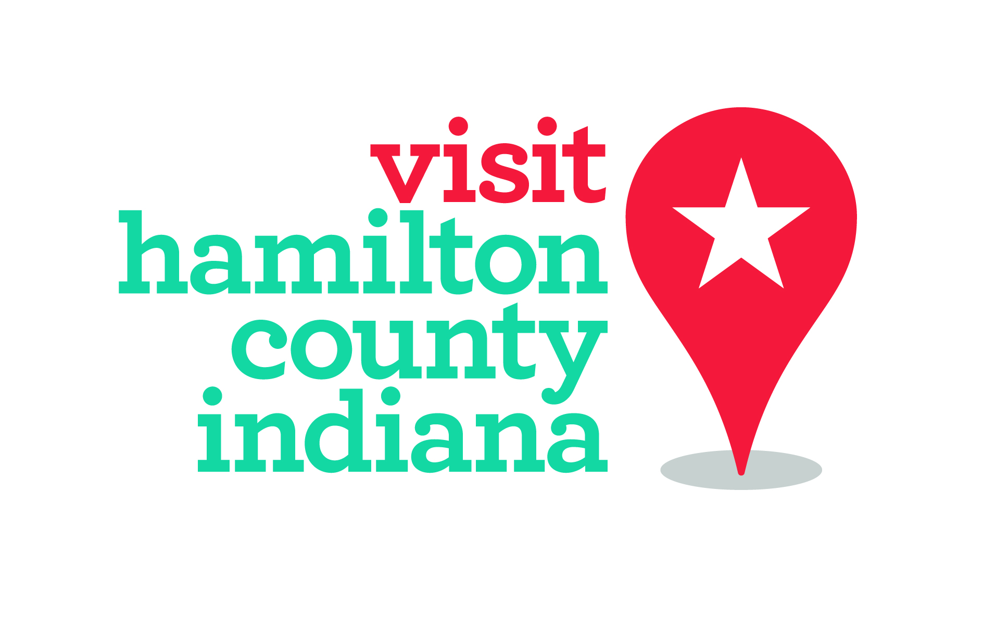
Contact:
Whitney Riggs
Communications Coordinator
wriggs@hamiltoncountytourism.com
317-660-4046/812-430-7320
Tourism College Courses Available for High School Students
Beginning this fall, students can learn the real world of hospitality, tourism and management and earn up to 18 college credits through Hamilton County’s Hospitality Immersion Certificate Program. This allows students to gain valuable paid field experience and a chance to work alongside one of the most vibrant tourism markets in the Midwest.

The pilot program, which is currently only open to Westfield High School students, is a partnership between Westfield Washington Schools, Ivy Tech Community College, IUPUI’s Department of Tourism, Conventions & Event Management (TCEM) and Hamilton County Tourism Inc.

The program allows students to choose six courses that will be taught by academics and industry professionals in areas of sports event management, special event planning, guest services, lodging operations, event marketing, food and beverage services and tourism travel development.

Introductory classes will begin for students their sophomore year and they will join the program their junior or senior year. All courses transfer from Ivy Tech Community College’s Hospitality Administration program to Indiana University’s TCEM program at IUPUI. Credits may transfer to other universities or could be used to support a minor in event, tourism or hospitality management.

As part of the program, students may opt to work in hospitality, tourism or event business during the summer. Many industry partners have agreed to be a part of the program by offering student internships.

Currently, Westfield Washington Schools is the only district participating in the pilot program. Other Hamilton County schools are being approached for the academic offering.

For more information, students can talk to their guidance counselor or go to www.VisitHamiltonCounty.com/hospitalitycertificate.

