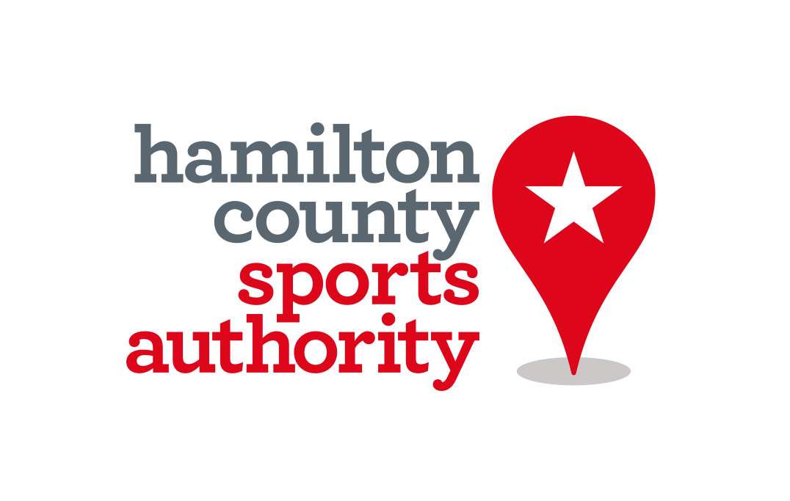

For Immediate Release
July 31, 2017
‘Try Archery’ Event Welcomes Community Participation
Event is part of USA Archery’s Outdoor Nationals at Grand Park this week
Hamilton County, Ind. – If you’ve ever wanted to test out your Katniss Everdeen skills, now is your chance. The public is invited to try archery as part of the USA Archery’s Outdoor Nationals at Grand Park Sports Campus in Westfield, Indiana.

The Try Archery Event will be at 9 a.m. to noon on Wednesday, Thursday and Friday on Field 22, and the community is welcome. Participants will sign a waiver and receive a brief tutorial from a USA Archery instructor before shooting. All participants must be 8 years or older and will receive an event bag with a water bottle.

The community event is part of the National Target Championships – the first-ever archery competition at Grand Park. More than 1,000 archers, including Olympians, World Champions and youth athletes, will compete.

Fans will get to see the U.S. and Junior Olympic Archery Development (youth program known as JOAD) National Target Championships, which are used for National Ranking for U.S. athletes and the selection of the national U.S. Archery Team.
The competition is free and open to the public. On Saturday evening for the U.S. Open Finals, tickets are available for purchase. The concession stand will be open for snacks and lunch.

Members of the media are recommended to attend the Try Archery Event on Wednesday morning when Hamilton County Tourism will host a partner event. Parking will be available in Lot E. See map attached.

For media questions or credential requests, contact media@usarchery.org.

For more information, visit here and follow U.S.A. Archery on Facebook, Twitter and Instagram.

About USA Archery
USA Archery is the National Governing Body for the Olympic sport of archery. USA Archery selects and trains Olympic, Paralympic, World Championship, and World Cup teams, as well as developing archery at the grassroots level across the United States. For more information, visit http://www.usarchery.org.
Media Contact
Sarah Bernstein/Public Relations
sbernstein@usarchery.org
201.919.8050

About Hamilton County Sports Authority
Hamilton County Sports Authority is a division of Hamilton County Tourism and provides many services, grants and assistance to make events successful. The organization can assist groups in many ways, including site selection, lodging and publicity. Visit www.visithamiltoncounty.com/sports.

Media Contact
Whitney Riggs/Communications Coordinator
wriggs@hamiltoncountytourism.com
812.430.7320

