For immediate release: | 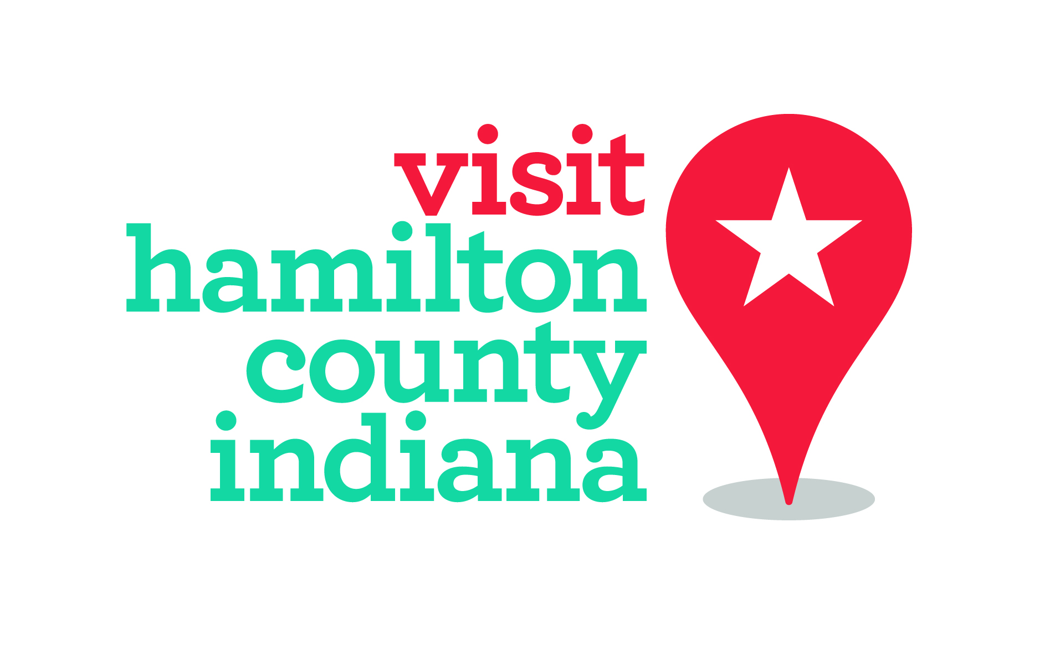
May 23, 2017
Whitney Riggs
wriggs@hamiltoncountytourism.com
317-660-4046/812-430-7320
USBR35 bicycling route launches during National Bike Month
Route connects 360 miles of biking trails across the Hoosier State
Hamilton County, Ind. – A 360-mile cycling route connecting 15 counties across the Hoosier state officially launches during National Bike Month. USBR35 is the first nationally-approved and interconnected cycling route in Indiana, making its way through Hamilton County.
The USBR35 project was approved in 2015 by the American Association of State Highway Transportation Officials with the help of Indiana Trails and the Adventure Cycling Association. The goal is to draw bicycle enthusiasts to Indiana by offering a unique Midwestern cycling experience that’s safe and accessible with bicycle travel options.
Richard Vonnegut, vice chairman for Hoosiers Rails to Trails Council, said the route offers not only a way to see the length of the Hoosier state, but a way to see many local features via slow and meaningful transportation.
“It shows off so many places which we Hoosiers call home,” Vonnegut said.
USBR35 includes the Indiana counties of Hamilton, LaPorte, Starke, Pulaski, Fulton, Miami, Howard, Tipton, Marion, Hancock, Shelby, Bartholomew, Jackson, Scott and Clark/Floyd (see map). The route is part of a nationwide movement to make an interconnected national network of roads for cyclists to easily travel across the country.
The project is part of a $20,000 grant from the Indiana Office of Tourism Development to make the state a more bike-friendly destination. To date, more than 11,000 miles of U.S. bicycle routes have been officially designated in 24 states. When complete, the USBR system will encompass more than 50,000 miles across the country.
For more information, visit www.indianaUSBR35.com or contact Whitney Riggs with Hamilton County Tourism at wriggs@hamiltoncountytourism.com.

National Bike Month
May is National Bike Month, sponsored by the League of American Bicyclists and celebrated in communities from coast to coast. Established in 1956, National Bike Month is a chance to showcase the many benefits of bicycling and to encourage more folks to give biking a try.

Hamilton County Tourism
The Hamilton County Tourism Inc. is a not-for-profit tourism organization that promotes Hamilton County, Indiana, to be nationally known as an innovative, diverse, vibrant and attractive tourism destination. We message, we move and we make it fun.
