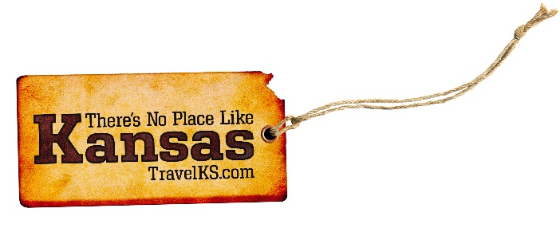
Contact: Kelli Hilliard
Phone: (785) 296-4922
Email: Kelli.Hilliard@ks.gov
Date: January 23, 2017
Photos: travelks.com/media/photo-gallery/

Kansas Towns Celebrate 150 Years on the Chisholm Trail
Branded as notorious stops along the Chisholm Trail, Kansas’ historic cow towns get set to revive their rowdy roots in 2017 during the 150th anniversary of the famed Texas-to-Kansas pathway. Indeed, the legions of longhorns left long ago, but the spirit and legends of the Chisholm Trail stand strong and proud from Abilene to Wichita to Caldwell and beyond.
Once-sleepy Abilene first hosted the unruly, gun-toting drovers and their rangy, grass-grubbing longhorns at the end of their 1,000-mile journey from Texas. Next, Newton, Wichita, Clearwater and others took a turn, unwittingly earning reputations as the roughest, toughest, wildest towns in the West. But, each grew tired of the violence, lawlessness and the cattle trampling their farmland, and the Texans were forced to find other railheads and markets. The Chisholm Trail that reached Abilene in 1867 faded away in the 1880s.
Today, 150 years later, a traveling exhibit, “The Chisholm Trail: Driving the American West,” traces the trail from its 1860s beginnings to modern times. The exhibit opens January 29-March 7 in the Symphony in the Flint Hills gallery in Cottonwood Falls. Created by Symphony in the Flint Hills and Flint Hills Design in Newton, the sesquicentennial original highlights the entrepreneurial story of the trail’s founding fathers, the drovers’ rugged life on the trail, the birth of the cowboy as an American icon, the famed “Old Chisholm Trail” song and movies, and includes several life-size metal longhorn cattle.
Following its debut, the exhibition travels across Kansas to Wichita-Sedgwick County Historical Museum, Wichita, March 9-May 2; Caldwell Opera House, Caldwell, May 4-June 27; Dwight D. Eisenhower Presidential Library and Museum, Abilene, August 24-October 17; Kauffman Museum, Newton, December 14, 2017-April 3, 2018; and Boot Hill Museum, Dodge City, September 20, 2018-November 13, 2018, with other locations to be announced.
Symphony in the Flint Hills continues its Chisholm Trail salute at its annual outdoor concert by the Kansas City Symphony on June 10. The day-long event in the Flint Hills takes place at Deer Horn Ranch in Geary County this year and includes talks about the Chisholm Trail, covered wagon rides, prairie hikes, cowboy poetry and a silent art auction. The day concludes with the sunset concert by the Kansas City Symphony.
Towns all along the trail have a roundup of special sesquicentennial events planned. Among the highlights:
--Abilene: At the Trails, Rails & Tales festival (September 1-3), cowboys drive longhorns through the streets and load them on the Abilene & Smoky Valley Railroad. Also, western musician Rod Steagall takes the main stage, along with cowboy poets, storytellers, musicians and historic re-enactors.
--Caldwell: Scoot your boots to Caldwell (May 5-7) for gun fights, saloon girls and cow camps during the Chisholm Trail Festival. Ghost tours, Women of the West re-enactments, a pub crawl, street dance, chuckwagon dinner, guided tours to Chisholm Trail ruts and a cowboy church round out the wild west weekend. Stop by downtown Caldwell any time to take the historical walking tour of trail sites and to see the metal silhouettes of cowboys and wagons along the actual Chisholm Trail on a bluff outside of town.
--A cattle drive along the original Chisholm Trail sets out September 12 from Pond Creek, Oklahoma, with stops overnight near Caldwell (September 16) and Clearwater (September 22), winding up September 23 outside Wichita. The public can visit the cow camps each day at designated times.
--Clearwater: The town’s Fall Festival (September 16-17) lives up to its “Happy Trails” theme with a parade, story-telling circles, cowboy poets and historical re-enactors. Also year-round in Clearwater, check out the 80-foot Chisholm Trail mural painted on the front of the Clearwater Historical Museum and a monument marking the trail.
--Ellsworth: Cowtown Days (August 18-19) marks two milestones: the trail’s sesquicentennial and the 150th anniversary of the founding of both Ellsworth and Ellsworth County. Reminisce at the Cowtown Parade, rodeo, longhorn cattle drive, live music and re-enactment of the shooting of Sheriff Whitney.
--Newton: Kansas Day at the Kauffman Museum (January 28) salutes the Chisholm Trail with a lecture on western trails by cowboy historian Jim Gray, a live longhorn, horse-drawn wagon, music and square dancers.
--Wellington: The first-ever Chisholm Trail BBQ Cook Off, a Kansas City Barbeque Society-sanctioned contest, gets fired up on April 28-29. High-tail it to the Kansas Wheat Festival (July 12-16) for heritage artisans and demonstrations, street dances, a parade, chuck wagons, quilt show and other trail-themed fun.
--Wichita: At its Fall Fair (October 6-8), the Historic Delano district recalls its unruly drover days with the re-enacted Running of the Doves by saloon girls, a Jesse Chisholm look-alike contest, campfire ghost stories, cowboy music, cattle drive, parade, chuck wagon cook-off, and cowboy music and artisans.
Also in Wichita, Old Cowtown Museum celebrates Chisholm Trail Heritage Days (September 2-3) with chuck wagon cooking demonstrations, cowboy music, cow chip-throwing contest, stagecoach rides and gunfights.
For more information: www.ct-150.com
###

