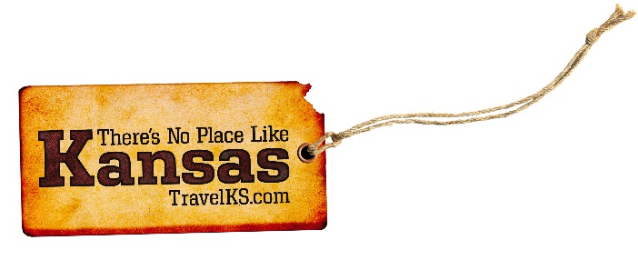
Contact: Kelli Hilliard
Phone: (785) 296-4922
Email: Kelli.Hilliard@KS.Gov
Date: April 19, 2017
Photos: travelks.com/media/photo-gallery/

Spring is Blossoming in Kansas

Flint Hills Discovery Center in Manhattan will celebrate its 5th anniversary April 14. Join the celebration and enjoy cake, live music and activities. $5 adult admission all weekend! Race in Manhattan’s only half-marathon along 7 miles of Bill Snyder Highway, through K-State campus and the only logical finish line in front of the Coach Bill Snyder statue The tantalizing smell of freshly-baked bread permeates Manhattan Conference Center, and the aroma is heavenly. On the third Saturday in June, bakers from all around the country will converge on Manhattan for the fifth National Festival of Breads, June 17. The 22nd year of Kicker Country Stampede will be better than ever in 2017 with huge breakout star Chris Stapleton and country legend Alan Jackson as the biggest headliners, June 22-24 at Tuttle Creek State Park in Manhattan. (VisitManhattanKS.org)

“Urinetown: The Musical” will be performed at the Dodge City, Kansas’ historic Depot Dinner Theater throughout April. This comical musical takes place in a Gotham- like city where a water shortage causes a town-wide ban on private toilets. The Depot will also be presenting “Beauty and Beast” this summer. Also coming to Dodge City this summer is a new restaurant and brewery called “Dodge City Brewing.” The brewery is the first of its kind in Dodge City and will serve brick-oven pizza along with their own hand-crafted beers. The brewery plans to open in May and is part of several renovations happening in Dodge City’s historic district. Long Branch Lagoon, a new family friendly water park opened last summer, a brand new hotel and RV Resort are currently being built, and a restaurant called Guymon Petro opened in December all within walking distance of the water park, located directly in front of World Famous Boot Hill Museum. So, what are you waiting for? Get the Heck INTO Dodge! (visitdodgecity.org)

Art galleries, shops and boutiques in the downtown Lawrence area have events, specials, and live music for Final Fridays on the last Friday of every month. On April 21st, the Downtown Olympic Shot Put event will take over the intersection of 8th and New Hampshire with 7 tons of crushed limestone, world-class athletes, and thousands of spectators. The Fourth Annual Food Truck Festival will be held in the Warehouse District on May 6th from 4pm-10pm. There will be 30 food trucks, live music and performances, and a beer garden. The always quirky, crowd-pleasing Busker Festival returns on May 26-28. There will be over 25 jaw-dropping acts on five stages throughout the weekend. Lawrence is expecting nearly 10,000 young athletes for the 51st USATF National Junior Olympic Track and Field Championships on July 24-30. Athletes will be competing at Rock Chalk Park. (unmistakablylawrence.com)

Stiefel Theatre for the Performing Arts in Salina, Kansas presents entertainment at a caliber not often found in a small Midwestern city. To date, the spring and summer marquee includes: The Marshall Tucker Band (4/20), Scotty McCreery (4/28), The Gin Blossoms (4/29), Salina Symphony (4/30), Garrison Keillor (5/23), Reckless Kelly (6/29), Toto (7/1), The Avett Brothers (7/4), Gladys Knight (7/22), Stephen Stills with Judy Collins (8/5) and The Piano Guys (8/16). Beyond diverse entertainment, the 1,200 seat Stiefel Theatre provides an intimate, nostalgic experience in a beautifully restored historic theatre, located downtown in the heart of Salina. Nearby local restaurants and shops enhance the experience, along with the SculptureTour Salina outdoor exhibition of 22 works on loan, the Smoky Hill Museum, Salina Art Center and Cinema and Salina Community Theatre. (VisitSalinaKS.org)

On May 4th, 2007, 95% of Greensburg, Kansas was destroyed by an EF5 tornado. But this is not what defines them. Greensburg has rebuilt as one of the greenest cities in the United States, has been featured as one of Budget Travel’s 2011 Coolest Small Towns in America, seen in 2013 USA Today’s Sustainability magazine, and appeared in the Planet Green’s series, Greensburg. In 2017, Greensburg will be celebrating 10 years of pioneering and innovation of rebuilding their community with sustainability in mind. Over the May 4-7th weekend, they will memorialize those who perished and will commemorate their successes and look forward to what the future has in store for the community. Discover Greensburg’s unique attractions and the rebuilt, restored and rethought community. (greensburgks.org)

Come to Winfield for the Kansas Sampler Festival, May 6-7! Get a taste of what there is to see, do, hear, taste, buy and learn in the state! Hear dozens of Kansas musicians perform, including Moreland and Arbuckle, Carrie Nation & and Speakeasy, Mountain Deer Revival, and the Kansas City Bear Fighters. Enjoy delicious Kansas foods, shop Kansas products, and sample Kansas beer, wine and spirits. Learn about all of incredible destinations to visit around the state. Lots of activities for kids! (KansasSamplerFestival.com)

If you’re looking for a unique getaway with hometown hospitality, Fort Scott, Kansas is the place for you! Whether you want to spend your time shopping and dining in our diverse Downtown Historic District, attending one of many live concerts and festivals, or enjoying the scenery on a tour at our local winery, lavender patch, or elk ranch, we welcome you to experience Fort Scott your way! Top off your trip with a cruise around the city on our narrated Trolley tour, a visit to the newly opened Lowell Milken Center for Unsung Heroes and an overnight stay at our award-winning accommodations. Conveniently located in “The Middle of Everywhere,” Fort Scott has all of the staples of history, unique shopping, fine dining and one-of-a-kind experiences waiting for you! (visitfortscottkansas.com)

For more information on these, or any attractions or events happening in Kansas, visit TravelKS.com.
###

