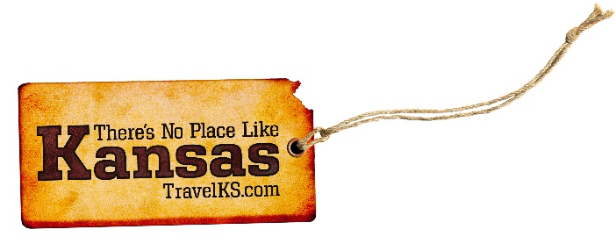
Contact: Kelli Hilliard
Phone: (785) 296-4922
Email: Kelli.Hilliard@KS.Gov
Date: April 15, 2019
Photos: travelks.com/media/photo-gallery/

Spring into Kansas

Get the Heck into Dodge City – Concerts, Races and Final Friday Events this Spring United Wireless Arena works hard at embracing our western heritage by hosting several County Music Artists each year. Upcoming concerts include Clay Walker -May 10th, and Trace Adkins - July 27th. Dodge City will kick off the summer season on Memorial Day weekend with Boot Hill Museum Gunfights and Historical Dodge City Trolley Tours. Dodge City Raceway Park opens its’ 2019 racing season April 6th. This race features DCRP Sprint Cars vs. URSS Sprint Cars, IMCA Modifieds, IMCA Sport Modifieds, IMCA Stock Cars, IMCA Hobby Stocks. Final Fridays in Dodge City are the hottest events in town. Enjoy socializing while viewing art on the last Friday night of every month starting at 4 PM. Check out Final Fridays in Dodge City on Facebook to see the most up-to-date information. (VisitDodgeCity.org)

Located in the Heart of the Kansas Flint Hills, Geary County, KS is home to many local, regional and national outdoor and historical destinations. Milford Lake is the Largest Lake in the State and known as the Fishing Capital of Kansas. You'll also discover three rivers to include the Headwaters of the Kansas River, Milford Nature Center and Fish Hatchery, Geary County Lake and Waterfalls, Hiking/Biking/Horseback Trails, Wetlands, KONZA Prairie, Hildebrand Dairy Farms, Kansas Arboretum and Acorns Resort Historic destinations include Fort Riley – Home of the 1st Infantry Division, Buffalo Soldier Memorial, Custer House, U.S. Cavalry Museum, Atomic Annie, State of KS Vietnam Veterans Memorial, C.L. Hoover Opera House, 1st Territorial Capitol of Kansas and the Grand Army of the Republic Memorial Arch. Geary County is located at I-70 and U.S. Hwy 77. Make 2019 the year you discover why Geary County, KS is your Outdoors and Historical Destination. (JunctionCity.org)

The pace around Manhattan moves at deliberate tempos preferred for laid-back visits, short restaurant waits and minimal traffic. That pace increases with arrival of Kicker Country Stampede music festival on MHK’s outskirts (Tuttle Creek Park, June 20-22). Stampede welcomes Jason Aldean, Old Dominion and Jake Owen among more than 50 musicians for three exciting days of outdoor music. Aldean croons: ‘You’re my inspiration, you take me places,’ on his hit single “You Make It Easy,” and Manhattan paves the way to relaxed entertainment. The beat carries to Symphony in the Flint Hills and MidFest MHK (June 15). Recipe inspiration rises in the form of National Festival of Breads amateur baking contest (June 8) at Manhattan Conference Center. Eight finalists qualify for final-day bakeoff for Home Bakers and Food Bloggers divisions. Finalists arrive from six states, California to South Carolina/Virginia. Make it easy, plan your next visit and “Oh, Manhattan!” moment. (VisitManhattanKS.org)

Don’t miss the fun in Salina the first weekend of May! Start Saturday at the SculptureTour Salina unveiling of 16 new sculptures at 11am. This event is loaded with fun activities for the whole family! After SculptureTour, attend Salina Comic Con (May 4th and 5th starting at 10am). Keep the excitement going Saturday evening as the Salina Liberty football team takes on Duke City and we celebrate STAR WARS Night! Join the fun and come in costume to both events at Tony’s Pizza Event Center! Salina’s “Official Kickoff to Summer” is the Smoky Hill River Festival (June 13th–16th). This weekend of fun includes music, food, fine arts and crafts, and more! There is truly something for everyone! Between the fun check out our unique dining and shopping options and end your weekend at Rolling Hills Zoo! Enjoy all kinds of fun in 67401 – one cool town! (VisitSalina.org)

Join the people flocking to the Northwest Kansas counties of Cheyenne, Sherman and Wallace the first weekend in May for the Big Kansas Road Trip. From May 2-5, the three counties will be throwing a giant party and everyone is invited! Visitors will be able to attend many special events throughout the area, visit area attractions and explore all the nooks and crannies and quirkiness that makes us who we are! BKRT 2019 is a chance to really see what makes these rural communities tick and appreciate them for who they are. This event is a partnership between the Kansas Sampler Foundation and the local communities. (BigKansasRoadTrip.com)

