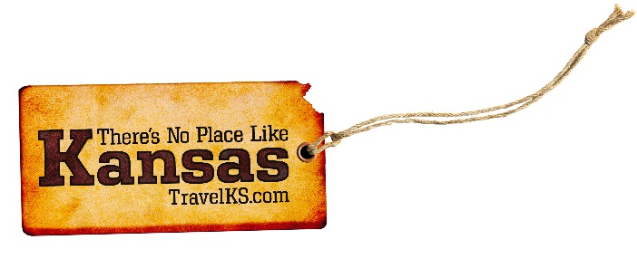
Contact: Kelli Hilliard
Phone: (785) 296-4922
Email: Kelli.Hilliard@KS.Gov
Date: January 9, 2018
Photos: travelks.com/media/photo-gallery/

Ready to Play in Kansas

Leavenworth KS is pleased to announce the opening of their newest hotel: THE NEW Home2 Suites by Hilton Leavenworth Downtown. Designed for travelers who want to maintain their normal routine, the new Home2 Suites by Hilton hotel features 107 suites and is one of the fastest-growing brands in the history of Hilton. Home2 Suites by Hilton Leavenworth Downtown offers all-suite accommodations with fully equipped kitchens and modular furniture. The hotel also features complimentary Internet, an expanded fitness area, laundry, Home2 MKT for grab-and-go items, and a complimentary daily breakfast that includes more than 400 potential combinations. Guests can also enjoy a heated indoor saline pool, fire pit, and grill area along with being pet-friendly. Located at 250 Delaware Street, Home2 Suites by Hilton Leavenworth Downtown is right across the Missouri River and offers guests convenient access to the Historic Downtown area featuring a variety of local dining and shopping options. (VisitLeavenworthKS.com)

Constitution Hall has announced the 2018 Program Series on Bleeding Kansas. Experts will be presenting talks and dramatic interpretations on the violent territorial and civil war of Kansas and of the nation.The programs will be held on Sundays at 2 pm from Jan. 28 - March 4 at Constitution Hall in the historic room where the Lecompton Constitution was drafted. Come feel the excitement of the times! For specific info on the topics and the presenters visit www.lecomptonkansas.com or call 785-887-6520. $3.00 admission fee for adults. (LecomptonKansas.com)

Begin 2018 with excitement, and embark on an adventure to Manhattan. The entertainment value continues to soar in MHK, with the excitement of Big 12 college basketball, McCain Performance Series events and fascinating exhibits at Flint Hills Discovery Center. The Wildcats play nine tough Big 12 opponents that include perennial powers West Virginia and in-state rival Kansas during January and February games, along with the Big 12-SEC Challenge that welcomes the Georgia Bulldogs. for a fabulous Saturday in Bramalge Coliseum. For more entertainment, McCain delivers sizzling shows like Cabaret, The Temptations and Jersey Boys. At Manhattan Arts Center, catch Wayne Goins and the Jazz All-Stars and the Railsplitters bluegrass tunes by way of Boulder. Flint Hills Discovery Center closes out its Duty First exhibit and welcomes the maze environment of the fully interactive Rainforest Adventure. Set your 2018 calendar setting to awesome, and book some valuable enjoyment time in Manhattan! (VisitManhattanKS.org)

For more information on these, or any attractions or events happening in Kansas, visit TravelKS.com.

###

