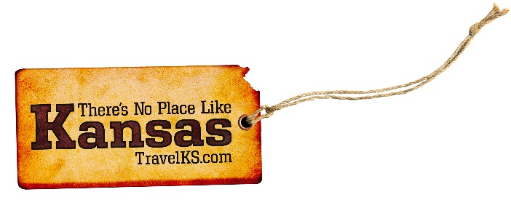
Contact: Kelli Hilliard
Phone: (785) 296-4922
Email: Kelli.Hilliard@KS.Gov
Date: July 13, 2017
Photos: travelks.com/media/photo-gallery/

End Your Summer in Kansas

Celebrate the old west in Abilene! August 2-5, 2017 Wild Bill Hickok Rodeo Named one of the “Top 5 Medium Outdoor Pro Rodeos” by PRCA, nearly 500 world champions and “young gun” contenders make their way to Abilene each year to compete for prize money and the hopes of qualifying for the National Finals Rodeo. August 4-5, 2017 National Cowboy Poetry Rodeo The Cowboy Poetry Rodeo is like a stock rodeo, designed to pit the skills of cowboy poets against each other. August 5, 2017 “Wild Steer” CASI Chili Cook-Off Sample chili from the best cooks in the state as they compete for the chance to represent Kansas at the Terlingua International Championship. September 1-3, 2017 Trails, Rails and Tales Celebrate the 150th Anniversary of the Chisholm Trail in Abilene, Kansas! Experience a real longhorn cattle drive, country western music performances, historic reenactors and more! (AbileneKansas.org)

The 57th annual Dodge City Days celebration is right around the corner and we want you to come "RAISE A RUCKUS" with us from July 28th to August 6th! Main events include our world class PRCA rodeo, BBQ’s, car shows, parades, street dances and much more! Also in Dodge City this summer is the Brothers of the Third Wheel National Trike-In from July 13 to July 16. Riders will visit many of the amazing Wild West attractions in Dodge City, take a day trip to Hutchinson, and cruise all over Southwest Kansas. Participants will also put on an evening parade of lights with their custom bikes through Dodge City on Friday and have a trike show in Wright Park in Dodge City on Saturday. So, what are you waiting for? Get the Heck INTO Dodge! (VisitDodgeCity.org)

Nearly 10,000 of the fastest and strongest youth athletes in America, ages 7-18, will travel to Lawrence, Kansas to compete in the USA Track & Field Hershey Junior Olympics Championships, July 24-30. This single-largest youth track and field meet in the nation will take place at Rock Chalk Park, home of The University of Kansas’ Track & Field team. With a seating capacity of nearly 8,000 and a new state-of-the-art Beynon surface, Rock Chalk Park is one of five IAAF Class I Certified tracks in the United States, making Lawrence a premier host for this year’s Junior Olympics competition. Athletes must qualify at Preliminary, Association, and Regional levels to compete in the Junior Olympics. Come and see the next generation of track and field stars compete at the highest level in Lawrence. Many of today’s Olympic Track & Field stars began competing in the USA Track & Field Junior Olympics. (UnmistakablyLawrence.com)

Lecompton (Kansas Territorial Capital), is the site of the writing of the controversial "Lecompton Constitution" for the admittance of Kansas into the union as a pro-slavery state. The document written in Constitution Hall, sparked a chain of events that divided the nation and eventually climaxed into the Civil War. It split the National Democratic party into Northern and Southern Democrats and Lincoln won in 1860 with only 39% of the vote. It was debated on the floor on Congress and in the President's office in Washington D.C. You may tour Constitution Hall and the Territorial Capital Museum. Lecompton was recently named "A Best Small Town in Kansas" by Kansas Magazine readers. (LecomptonKansas.com)

Manhattan gets geared up for the college football season ... oh, about the time everyone gets holiday lights packed away. On Sept. 2, K-State opens its 50th season at Bill Snyder Family Stadium against Central Arkansas for the annual Family Reunion, and hosts six more big football contests in Manhattan (Big 12 games feature Baylor, TCU, Oklahoma, West Virginia and Iowa State). More late-summer features include the Duty First exhibit (100 Years of the Big Red One; Aug. 26 open date) at Flint Hills Discovery Center. To get you through the end of July, watch the rodeo pros from PRCA bustin’ broncs at the Kaw Valley Rodeo (July 27-29) during the Riley County Fair (CiCo Park Fairgrounds). The 2017-18 McCain Performance Series opens Sept. 8 with the smart, observational humor of comedian Paula Poundstone, followed by The B-52s (Sept. 29) and John Cleese Live (Oct. 5) among more featured shows. (VisitManhattanKS.org)

Visit Salina this summer…it’s an art! Salina is known for an artistic vibe that is unparalleled even in considerably larger communities. Public art is unavoidable, from our thoroughfares to our public works! SculptureTour Salina 2017 in historic downtown features 22 pieces. Theatre, music, exhibitions and art cinema are all a part of this beautiful kaleidoscope. Salina Community Theatre features productions year-round. Concerts, comedy, and the Salina Symphony are among offerings at Stiefel Theatre. Exhibitions and a popular art cinema are presented by Salina Art Center. Discover rich Kansas heritage at the Yesteryear and Smoky Hill Museums. Stroll through Prairie Lavender Farm to our north. The KKOA Leadsled Spectacular Car Show is in Oakdale Park, July 27-30. Nothing beats Rolling Hills Wildlife Adventure’s Zoo and Museum for the whole family. Cool off with a splash at Kenwood Cove. Find artful hospitality, dining and shopping when you Visit Salina this summer! (VisitSalina.org)

For more information on these, or any attractions or events happening in Kansas, visit TravelKS.com.
###

