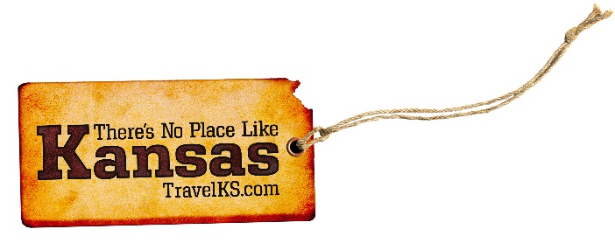
Contact: Kelli Hilliard
Phone: (785) 296-4922
Email: Kelli.Hilliard@KS.Gov
Date: October 18, 2017
Photos: travelks.com/media/photo-gallery/

Tis’ the Season in Kansas

The “Rooster Roundup” Tagged Bird Contest in Southwest Kansas, with Bounty Birds in Dodge City, begins in November Southwest Kansas is THE PLACE to hunt pheasant this season. The annual “Rooster Roundup” contest takes place in multiple Southwest Kansas communities including Dodge City, Garden City, Liberal, Ulysses, Jetmore, and Hugoton. An additional 100 banded pheasants or “Bounty Birds” will be released in Ford County during the contest that runs November 11, 2017 to January 31, 2018. Winners of “Rooster Roundup” birds and “Bounty Birds” will be entered into a drawing for prizes announced after the end of Pheasant season. The “Bounty Bird” bands are associated with additional prizes. If you bag ANY of these banded pheasants, bring the leg band to that community’s registration point to register the band and be entered into the drawing. (VisitDodgeCity.org)

Unique events, excellent shopping and a festive atmosphere make Lawrence, Kansas the perfect holiday destination. It all kicks off when the local fire department rescues Santa from the top of Weaver’s Department Store and the mayor flips on the lights in Downtown Lawrence on Friday, November 24. See more than 50 trees and 20 wreaths elaborately decorated by locals at Liberty Hall during Festival of Trees, November 27-30. Winter Wonder Weekend, December 1-3, has everything you need for holiday shopping, dining, and entertainment! The highlight of the weekend is the Old-Fashioned Christmas Parade on Saturday, December 2. This exclusively authentic horse-drawn carriage parade is one of the most unique in the nation! Other Winter Wonder Weekend events include the Gingerbread Festival, Live Caroling, Santa visits, special treats and shopping deals. (UnmistakablyLawrence.com)

See the LARGEST display of CHRISTMAS TREES in the MIDWEST. The Territorial Capital Museum in Historic Lecompton, Kansas which is the "Birthplace of the Civil War, Where Slavery Began to Die." is the location of this unique display of 120 trees and ornaments. The trees contain a fabulous collection of victorian, antique, collectable and theme decorations on three floors in the museum, all handicapped assessable. The display will be from November 1 to January 1 2018. The hours are 10 AM to 4 PM Monday -Saturday and 1PM to 5 PM on Sunday. Lecompton was the offical Territorial Capital from 1855 to 1861 and recently named one of the "Best Small Towns in Kansas under 5,000 population.and one of the 70 Bucket list items by Kansas Magazine. (LecomptonKansas.com)

The 1st Infantry Division has historically been the U.S. Army’s first “boots on the ground” in any combat theater. The tribute to generations that have carved out hardened battle paths continues on display at Flint Hills Discovery Center in Manhattan. Duty First: 100 Years of the Big Red One exhibit opened just before Labor Day weekend and continues into January. Free lectures complement the exhibit with Nov. 4 special event, Canteen & Cocktails: A Night in the 1940s. On the Kansas State University campus, McCain Performance Series features Dirty Dancing (Oct. 22), Martina McBride: Joy of Christmas (Dec. 2) and Manheim Steamroller (Dec. 21) among many more exciting entertainment shows throughout 2017-18. Ahead of the holidays, be certain to catch Manhattan Festival of Lights, Lighting Ceremony, Nov. 24 at Blue Earth Plaza, with 60-foot tree and introduction of Santa Claus to welcome the holidays in The Little Apple®. (VisitManhattanKS.org)

Located in central Kansas, Russell County, has fun waiting just for you! Drive, ride, or walk the beautiful Post Rock Scenic Byway that will lead you by breathtaking Wilson Lake, and drop you off at art loving Lucas. Granny Mae’s Pumpkin Patch, rural Dorrance, promises a corn maze, pumpkin patch, fire pit, and enjoy the best of Fall scenery. The Resurrection Inn, downtown Russell, is a haunted house set in the basement of the stone brick Masonic Lodge, and is sure to create a scream. Take the back roads to A Fairport Knight, in Fairport. This limestone cabin is decked out for Halloween and will be for Christmas as well. Live concerts, craft/vintage shows, art shows, we have it all this Fall in Russell County. (RussellCoKS.org)

For more information on these, or any attractions or events happening in Kansas, visit TravelKS.com.
###

