Tour Kansas Microsite Tutorial

Updating and Adding Tour Kansas Website Listings

- Make sure you have access to the Extranet Portal. This will allow you to manage your accounts and website listings.

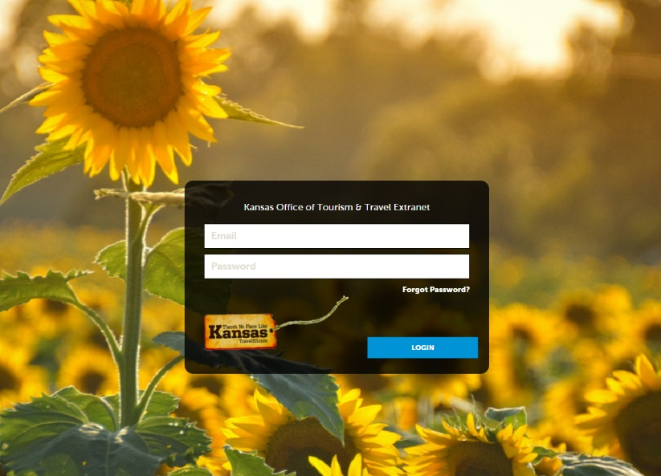

- If you do not have access, please contact Logan Hildebrand at Logan.Hildebrand@ks.gov.

- Once you have access, log in and check to make sure the facilities in your area have an account. Click “Profile” in the left navigation column and then click “Accounts.”

- If a facility is not listed, email Logan a list of everything that needs added. She will need the name of the facility, address, phone, general email, website, and contact information (name, title, phone and email).

- She will create the account and once that is complete you will have access to the account(s) and will be able add them to TravelKS.com.

- For more details on adding a new website listing, adding contacts, etc. please refer to the TravelKS.com Training Center tutorials - https://www.travelks.com/industry/education/travelks-training-center/

- If you have made the website listing only for the Tour Kansas page you will need to go into Collateral and tag the listing with the "Tour Kansas” category AND the “Tour Kansas (your community)” as a subcategory.
Video Tutorial: https://www.screencast.com/t/kvNeuFvXD

OR if you want to use the same information from your TravelKS.com website listing, you will need to tag it with “Tour Kansas” as an additional subcategory (you can pick multiple categories from this list.
Video Tutorial: https://www.screencast.com/t/lgCPUBHiI

Whichever you choose, will allow the website listing to show up on www.TourKansas.org

Updating the TourKansas.org Website
- Log In: https://kansas.simpleviewcms.com

- You should have been emailed this link & a temporary password, if you have forgotten your password then just hit "forgot password". https://www.screencast.com/t/GAz3CZGW7keB

- On the left hand side click on “Sitemap” and then “Primary” and “Microsites.” The Tour Kansas Microsite should be listed. Click on the green dropdown arrow and click on “View Children.” This basically takes you to the navigation that appears on the left side of the website.

- To update your individual destination pages click on the green dropdown arrow again and then you will click on “View Children” again.

- Now you will see all the cities that are available to choose from. Choose your city and click on the blue edit content button (pencil & paper).

- Once on this page, you will be able to see a screen shot of the page you are wanting to edit. Whatever your mouse hovers over on the left will show a box on the right what you will be working on.

Here is a video tutorial to watch up until this point: https://www.screencast.com/t/t7yvpJ52h

Edit Photo

- If you’d like to edit the photo that appears at the top, click on the green gear button for “Collection Templates- Header Interior” and choose “edit.” Then you will need to choose “browse” and then “create new” to select a new photo.

- Now you should be on a page that reads “Create New Header Slide.” If so, click on the blue “images” box and then on “create new” on the following page. From there you will upload your image file and save changes.

- You will then need to select your photo and then create a title, with an option to put a location and description, and link to a listing on our website. Save your changes and then select the image again. You will then need to delete the old photo and hit the blue “save changes” button. Your new photo should show up on the left preview page. If it looks correct click on the blue “save” button at the top and your page will be updated. If you don’t like the way it looks just click “cancel” and it will revert back to the old page.
Video Tutorial: https://www.screencast.com/t/MVxhA3U6DTV

Edit Main Text Box
To edit the text that appears under your photo, click on the green gear button for “Text-Text Box” and choose “edit.” Make any edits you see need to be done and click the blue “save changes” button. Your edits should show up on the left preview page. If it looks correct click on the blue “save” button at the top and your page will be updated. If you don’t want to save your edits just click “cancel” and it will revert back to the old page.
Video Tutorial: https://www.screencast.com/t/VmFBBEMAosE

Edit At-A-Glance Text Box
To edit the text that appears under main text box for At-A-Glance, click on the green gear button for “Text-Text Box” and choose “edit.” Make any edits you see need to be done and click the blue “save changes” button. Your edits should show up on the left preview page. If it looks correct click on the blue “save” button at the top and your page will be updated. If you don’t want to save your edits just click “cancel” and it will revert back to the old page.
Video Tutorial: https://www.screencast.com/t/PnejirpU

Please check out the Merriam page for a good example of how your page should look:
https://www.travelks.com/tourkansas/partners/merriam/

