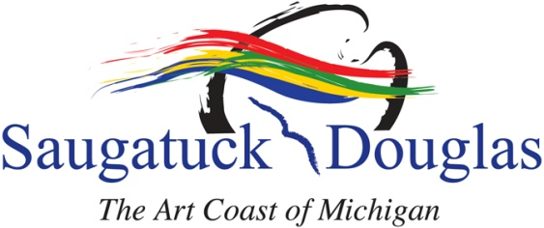
Saugatuck/Douglas Convention and Visitors Bureau, P. O. Box 28, Saugatuck, MI 49453 (269) 857-1701 Fax: (269) 857-2319

Saugatuck/Douglas Area Convention And Visitors Bureau, Inc.
Assessment Collection Policy
RE: Delinquent Accounts

For each month in operation, each active member shall send the legally mandated monthly payment, deposit coupon, monthly occupancy rates, statement of room charges and monthly state use tax returns to the Certified Public Accountant for the Saugatuck/Douglas Area Convention and Visitors Bureau (hereinafter referred to as “the Bureau”). This information and documentation shall be provided to the CPA in a format acceptable to the CPA within 30 days of month end, at the following address:

Meyaard Tolman Venlet, P.C.
P.O. Box 320
16 East Main Avenue
Zeeland, Michigan 49464

For purposes of this Assessment Collection Policy, an active member shall be considered delinquent if the member fails to pay a monthly assessment, including any collection fee, interest and delinquent charges, and/or fails to submit a statement of room charges and/or monthly occupancy rates and/or state use tax returns. If the monthly two percent (2%) assessment is not paid or if the monthly statement of room charges, occupancy and/or state use tax returns are not submitted within the time parameters set forth in the Community Convention or Tourism Marketing Act (1984 Michigan Public Act No 59), the following collection policy shall apply:

COLLECTION PROCEDURE:

Step 1:
As a courtesy, a certified letter will be sent by the CPA to any delinquent member, reminding them that their payment of assessments and/or submission of statement of room charges, occupancy and/or state use tax returns is delinquent if the same has not been paid and/or submitted by the due date. It is the member’s sole responsibility to provide the CPA with current name, address, and contact information for all notifications of delinquent accounts. If the member specifically requests, this notification may also be made by e-mail to an e-mail address provided by the member, which shall be deemed a courtesy only. These notifications are triggered at 30 days after applicable reporting period month end.

Step 2:
If the member does not remit payment or deliver records that are required within fifteen (15) days of the date of mailing the certified letter referenced in Step # 1 above, the CPA shall notify the Bureau of the delinquency and shall provide information as to the delinquent month(s) of assessments, occupancy rates, statement of room charges, and/or state use tax returns to the Bureau.

Step 3:
The Bureau shall then remove the delinquent member from:
▪ the lodging (website) data base, including; phone and all similar databases.
▪ the office phone referral list
▪ any and all ongoing or current Bureau promotions, programs and activities.

Step 4:
If the member remains delinquent for a period of sixty (60) consecutive days, the attorney for the Bureau shall institute legal proceedings against the delinquent member. The attorney shall provide the Bureau with copies of all court pleadings. Once the attorney has taken any action toward litigation, such as correspondence, research, ordering a title search or otherwise, the delinquent member shall be responsible for all attorney fees and costs incurred in pursuing collection. The Bureau shall provide all relevant and necessary collection information to the attorney.

PENALTIES:

The member shall become liable for a collection fee of seventy-five dollars ($75.00) when the CPA has enacted Step 1 of the Assessment Collection Policy by the sending of a certified letter from the CPA to the member.
The Bureau shall charge and collect a reconnection fee to compensate the Bureau for website maintenance fees and staff time as well as incentive to members to remain current, as follows:

▪ 1st instance = $75.00
▪ 2nd instance = $150.00
▪ 3rd instance & all subsequent instances = $350.00

When the Bureau is notified of the delinquent account (Step 2), the member will immediately be excluded from participating in the Bureau’s activities including marketing programs (e.g. promotions, packaging, website, etc.), and the member will be removed from the Bureau’s website and mobile sites. All assessments must be kept current and completely up to date to retain voting privileges. If the Bureau receives notification that a member has rectified all delinquencies and upon payment by the member of all assessments and penalties set forth in this policy the member’s eligibility for participation in the Bureau’s activities and marketing programs will be reinstituted in the following month.
A delinquent member of the Bureau will not be allowed to advertise in the annual Visitor’s Guide if that member is in arrears in any amount (assessments, late payment interest, penalties, collection fees or any other amounts covered in this policy) at the publication deadline.

Adopted by the Board of Directors of the Saugatuck/Douglas Area and Visitors Bureau on June 20, 2011.

