MARKET REPORT SPAIN. JANUARY 2022

Economic perspective

The Spanish economy is recovering a little slower than expected. Main reasons are our high dependence in tourism and the crisis in supplies which has affected the car manufacturing sector which is quite important for the Spanish economy too. Employment is however having a more positive development than the overall economy.

The expectations from Spanish National Bank are good and anticipate a recovery at a good pace over the next three years. In the short term, the economy is still affected by “Omicron”but it is expected to recover as tourism is back and the distribution gets back to normal.

All this recovery process will be supported with the projects financed through the Next Generation EU program.

GDP growth was expected to be 4.5% in 2021, 5,4% in 2022 and 3.9% in 2023. If predictions come true, GDP will be at the same level as before the pandemic between end of this year and beginning of the next.

SOME ECONOMIC HIGHLIGHTS

- With a GDP of $1.2 billion, Spain is the 4th economy of the EU - save for that of the United Kingdom - and the 14th in the world.
- Spain is the 13th recipient of foreign investments in the world.
- More than 14,600 foreign firms have set up their business in Spain.
- 70 out of 100 top companies in Forbes Global 2000 operate in Spain.

Present COVID situation

At the moment of the creation of this document (February 2022) we can say that Spain is getting out of the sixth wave of pandemic. The incidency is still high but 94% of the cases are Omicron and every day there is less pression in hospitals.

The vaccination process has been a success in Spain and now 81% of the total population are fully vaccinated and 87% have received at least one dose.

Some figures…. Bednights evolution during the last years

In 2019 Spain accounted for 3% of the total volume of tourists to Norway. Traditionally Spain has been a summer market, and especially in August Spanish traffic is vital for some destinations in Norway. The Spanish market has experienced an increase of 9% in bednights between 2007 and 2019. In recent years the figures have been stable, but we have seen an increase outside the summer season, especially in winter and May, June and September. This is a wanted development, in line with our strategy of selling ‘All Norway All Year’.

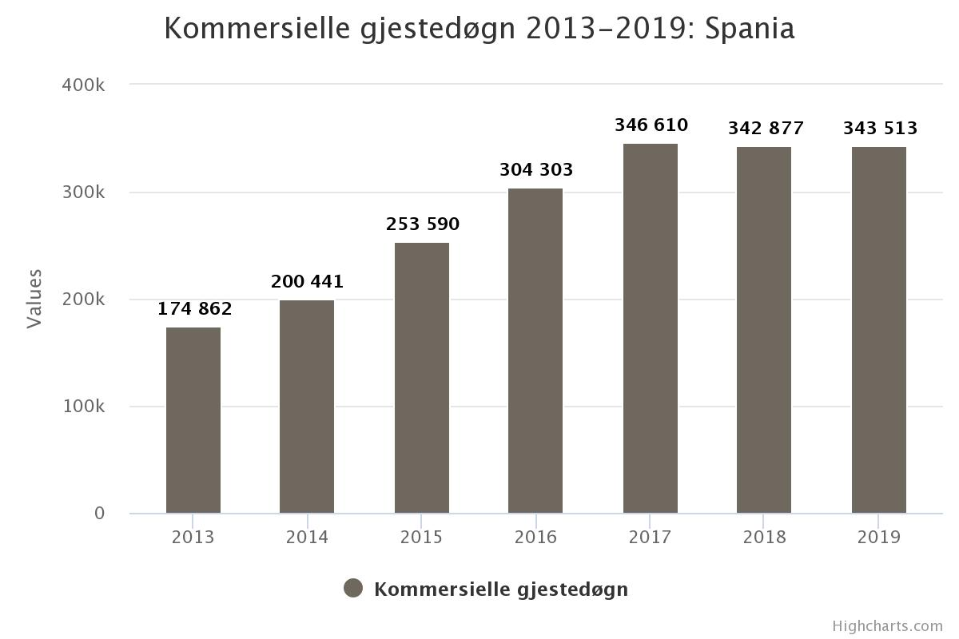

As in the rest of the world, 2020 was a dramatic year for tourism in Spain and the traffic to Norway went down to a minimum. Studies done during 2021 showed a high interest of Spanish to travel but tourism in 2021 was mainly domestic.

For tourism between Spain and Norway, it was not a good summer. The borders to Norway were open very late (later than other competing destinations) and the travel trade did not have time to react and have their products ready. Besides, the market was not ready for traveling abroad.
The following chart shows the figures for the whole year 2021 compared to 2020 and 2019. There was an increase of 62% in bednights compared to 2020 but we were still with -80% of the tourists reported in 2019.
Perspectives for 2022 are very positive. Tourism abroad is back and there is an increasing interest for Norway among Spanish travelers. Tour operators have published their programs and they are already promoting them and booking allotments. Most of them have anticipated the season and are starting their programs in April and May. We still have a challenge with the flight capacity and fares but hopefully this will be solved during the Spring.

Whats up in the Spanish travel sector

This pandemic has been dramatic for the travel industry in Spain, but we have not seen many bankruptcies so far due to the fact that the Government has been subsidizing temporary unemployment for the tourism sector.

However, big chains are closing part of their outlets and still many tourism employees are working part time or they are on temporary leave. The situation with the travel sector has not reached the “normal” level and the predictions are to have big reductions in staff and outlets in the big travel corporations.
The main big news during the pandemic was the creation of two large tourism groups. One is the result of the merge of the biggest travel companies in Spain: Globalia and Avoris. The new company is run by Barcelo Group, and it has an annual turnover of 4 billion €. This group has more than 6.000 employees and 1.500 outlets. Before the merge, Globalia represented brands like Air Europa, Travelplan, Halcon Viajes, Ecuador or Welcomebeds, among others. Avoris represented Barceló Hotels, B The Travel Brand, Special Tours, Catai, Quelonea and more.
The group will keep the name AVORIS. For the moment, no big changes have taken place in regards to staff or brand reduction but this is expected to happen at a certain point. Some of the companies belonging to this group are important tour operators for Norway and it is important to keep an eye on them.

The second group is W2M. This group belongs to the company Iberostar and has some important brands for the Spanish tourism: airlines, travel agencies, event companies, hotels and tour operators. The most important companies for Norway in this group are the tour operators Marco Polo and Icarion. Icarion has done a very strong bet on sustainability and they will be a very important partner for Norwegian tourism.

Another change in the industry which can be relevant for Norway is the birth of the new Politours. Politours had a bankruptcy and they started a new company with a more modern approach. Norway is one of their destinations.

High end agencies like Utopica (from El Corte Ingles), Pangea or Nuba are seeing a great demand and they keep working with tailor made products for the most demanding customers.

Changes in travel patterns and trends

2022 seems to be the year of the recovery for tourism in Spain. The first sign was the success of the travel fair Fitur in January, with a participation level far beyond expectations. According to Guillermo Albizuri, Director of Tourism for Google in Spain, recovery will be fast as soon as restrictions are removed and according to a study done by the platform Observatur tourism is expected to reach 2019 levels during the second semester of 2022.

According report Informe Temporada 2020/2021 from ObservaTUR the travel industry is already under a transformation which reflects in more concentration, new technhologies applied in all phases of travel and new ways of understanding the relationship with the client.

Studies by ObservaTUR and Amadeus show similar facts about trends in the Spanish market:

- Security will be a decisive factor when booking, selecting means of transportation, accommodation - and even the destination.
- Professional service and information will be one of the most important values travel agencies need to offer. They need to give the latest news about health and restrictions in different countries and also need to be able to personalize the trip and give the best service and knowledge to the traveller.
- Technology and digitalization.
- Price will be even more important than in the past when selecting a product or a destination.
- Flexibity in Booking and cancelation policies.
- Destinations which are considered safe, sustainable and with no massification. Travelers will travel for longer, focusing on quality and security instead of short and frequent trips like before COVID.
- Domestic travel is starting before international.
- Young people (under 39) and couples will be the first groups to start traveling. Followed by families and mature people.
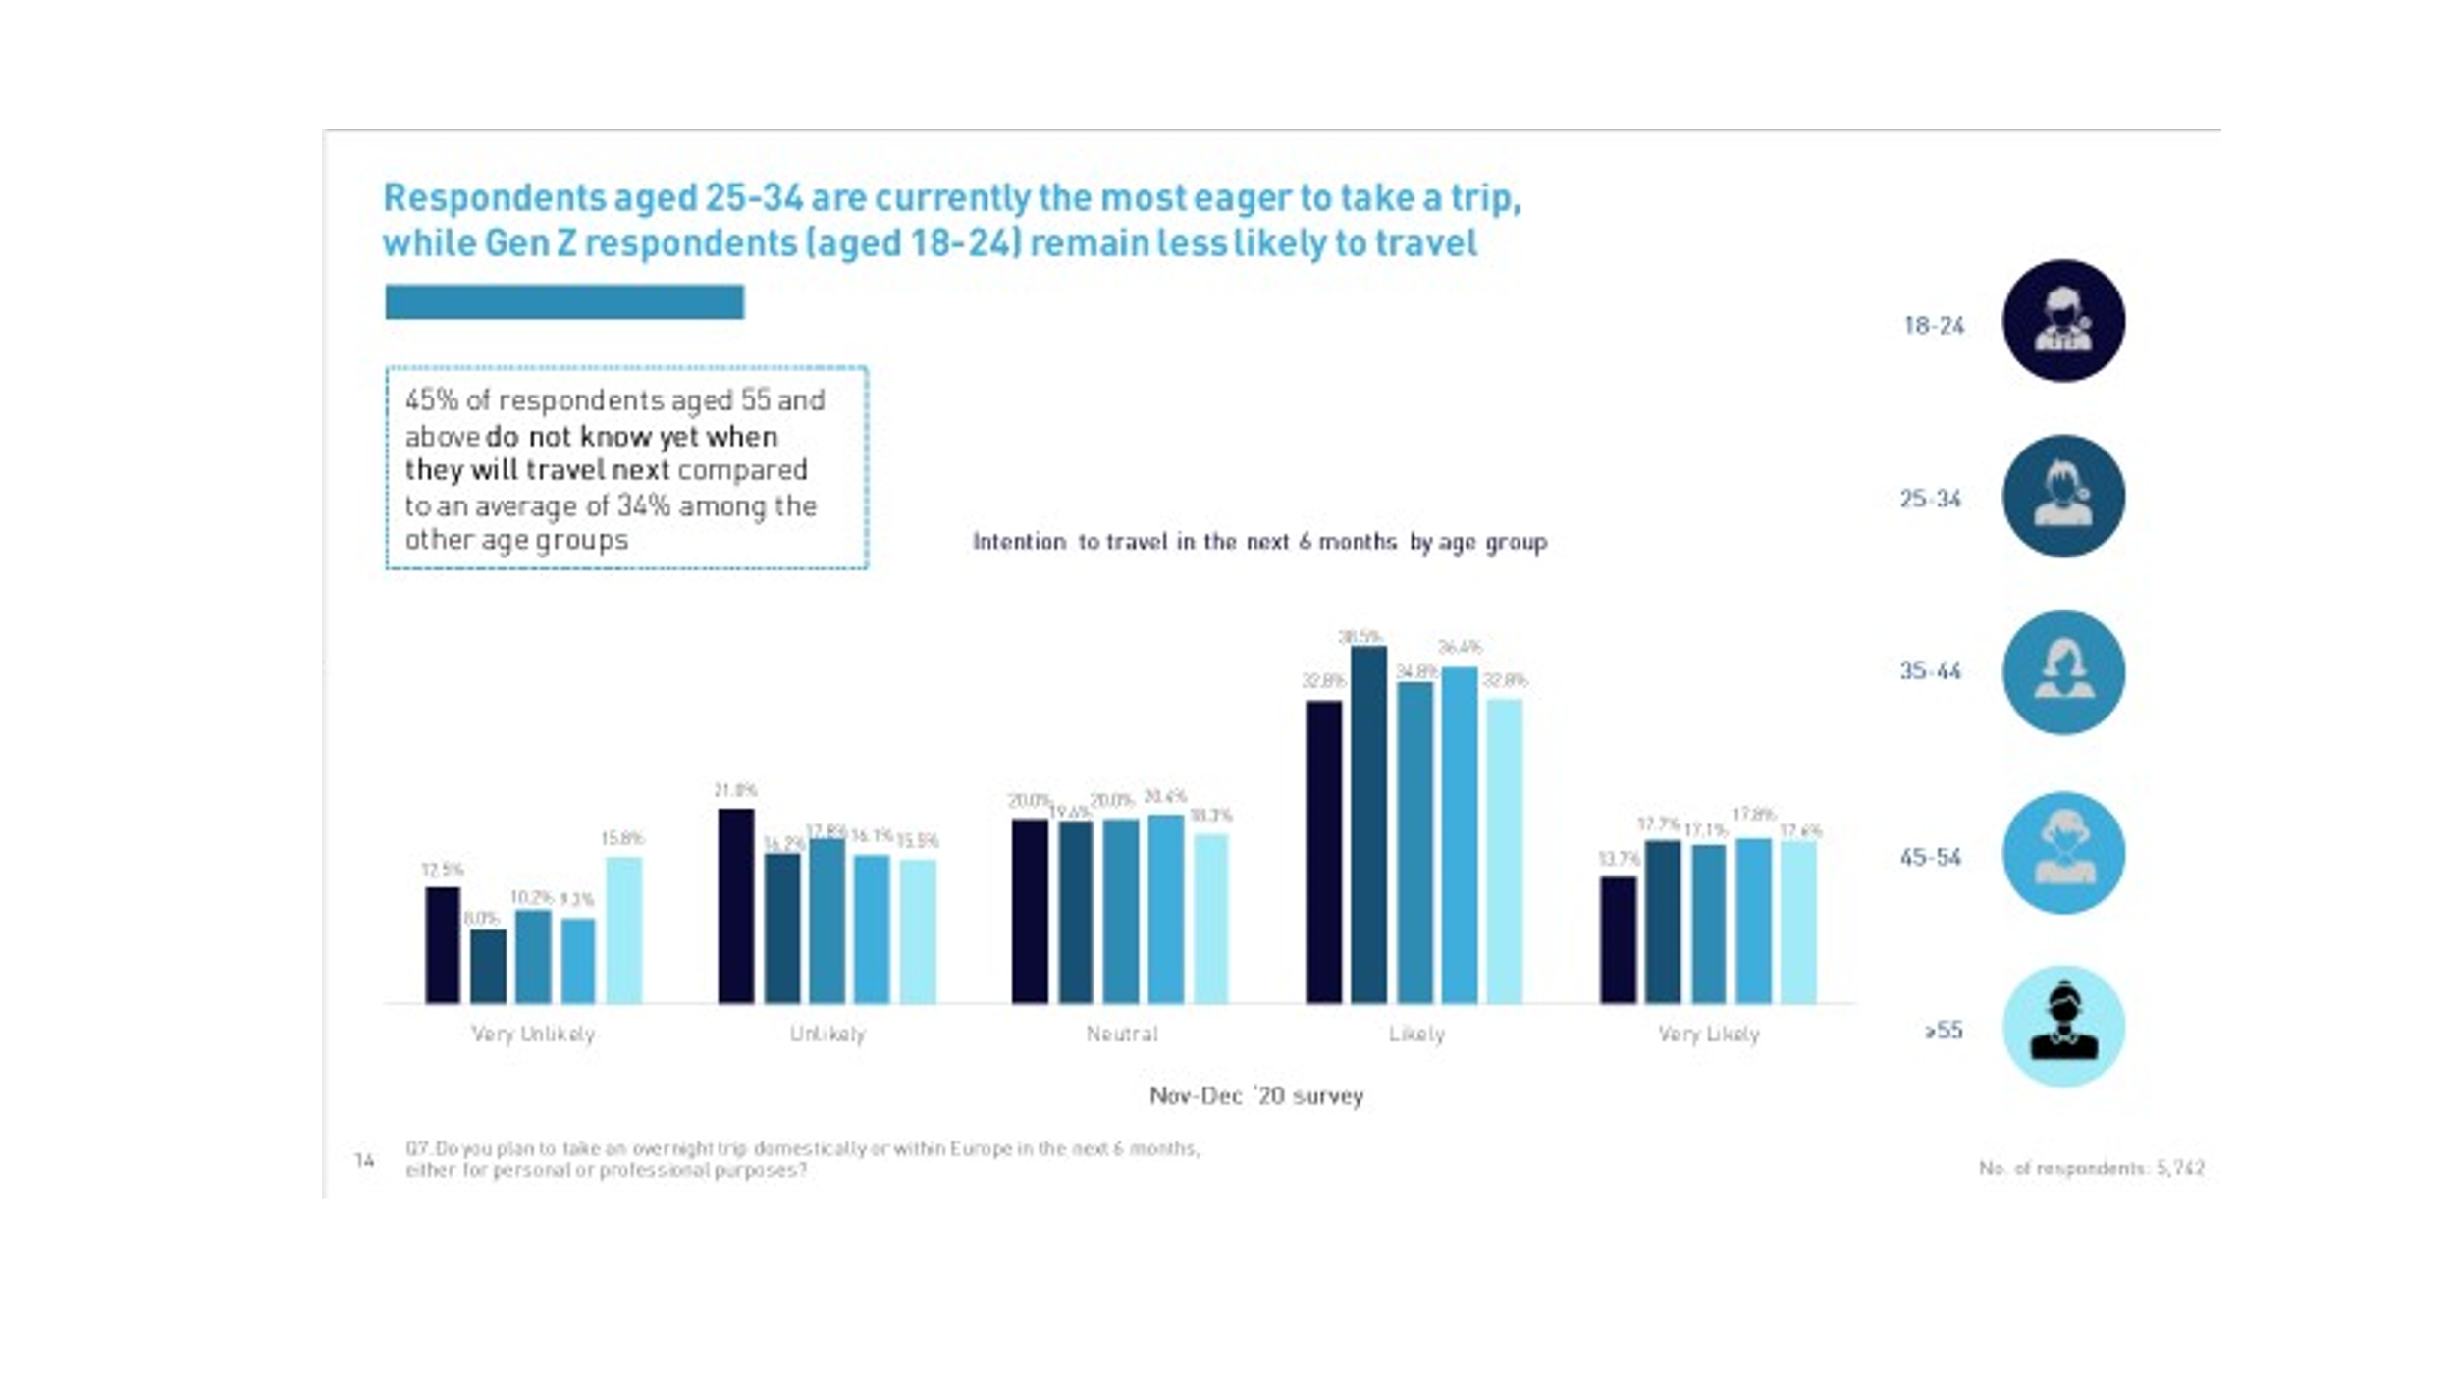
- Leisure will recover before business travel. 70% of respondents said they would travel immediately or between one and three months once restrictions are over.

According to more recent researchs done by Expedia, Observatur and American Express, more than 55% of Spanish travelers are planning to travel in 2022 like before the pandemic, and we can already see some new trends for 2022:
- Spanish people will spend more in travel than in 2019. According to American Express 14% more.
- Trend to combine business and leisure and to do homeworking outside home.
- People are still travelling domestic and to close destinations but as restrictions are over people start looking at the world.
- Travel slow with a concern for local cultures and for sustainability. 49% of the respondants showed a concern for the footprint of travel and for sustainability.
- Fly & Drive
- Travel with a meaning for personal enrichment.
- Gastronomic and enoturism.

