Pressetrip: National Tourist Routes in Fjord Norway

Date: August 20th – 24th 2014
Number of participants: 10+1+1+1

Tour coordinator: Fjord Norway

Per Ritzler, The National Tourist Routes
Mona Konuralp, Innovation Norway

WELCOME TO FJORD NORWAY www.fjordnorway.com
Fjord Norway is a region which consists of four different parts; Rogaland, Hordaland, Sogn & Fjordane and Møre & Romsdal. In Fjord Norway you will find a land of contrasts. You find beautiful and peaceful nature sceneries, but also all kinds of wild activities. From wandering on long white beaches in March you can go to skiing in July on snowy glaciers. Fjord Norway has everything you could wish for. Mountains, Fjords, Glaciers, Quietness, Beautiful nature, Adventures, Activities - Everything you need.

Fjord Norge AS/Fjord Norway is regional tourist board of Western Norway - the site of the world famous fjords! Our expertise is invaluable in your planning, and helps secure the quality of your trips to the fjord region. Fjord Norway can assist with fam. trips as well as press tours for travel correspondents. Our product manual, travel brochure, posters and newsletters are necessary tools for your planning. Fjord Norway’s Internet presentation www.fjordnorway.com contains detailed information as well as a wide selection of photographs for you to use free of charge (www.fjordnorway.com/imageshop). Fjord Norway is located in Bergen, Norway and is owned by transport companies, hotels, tourist organizations as well as activity and adventure providers in Western Norway.

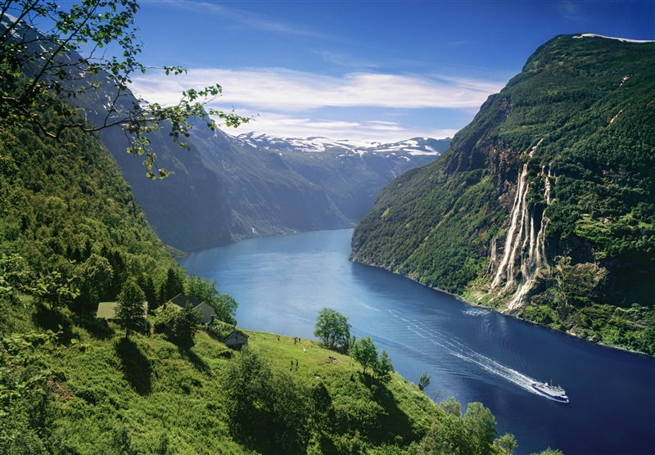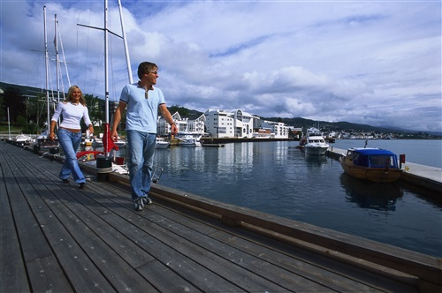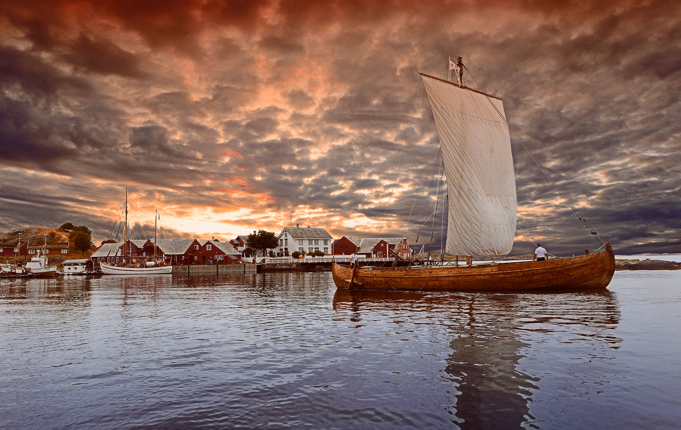

National Tourist Routes in Norway
There are still roads that are not merely designed to get you to your destination as quickly as possible. National Tourist Routes are beautiful drives with that little bit extra. The routes are carefully selected by the Norwegian Public Roads Administration, and each of the 18 routes has its own history and character. Our job is to make sure the routes are adapted to travellers' needs. We do so by building spectacular viewpoints with service buildings, car parks, furniture, paths and art.
www.nasjonaleturistveger.no

Twitter/Facebook/Instagram: @fjordnorway @visitnorway
20th August Wednesday
Arrival Kristiansund http://www.visitkristiansund.com/en/
- Sightseeing and Varden Viewpoint
- Lunch
- After lunch: Departure to Kårvåg and boat crossing to the fishing village of Håholmen. Time: appr 1 hr.

Håholmen Fishing Village
Ragnar Thorseth's 18th century fishing village, with its original wharves, traditional fishermen's shanties and bakery. The seaward side of this 12-acre island faces directly onto the ocean and the shipping channels. On the landward side there is a sheltered natural harbour with thirty or so buildings, several dating from the 17th and 18th centuries.
http://www.classicnorway.com/hotels/haholmen-havstuer

Fishing trip at Håholmen in the afternoon.

Dinner at Håholmen
Overnight in
Håholmen Havstuer
Tel: +47 71 51 72 50 / email: post@haholmen.no
http://www.classicnorway.no/hotell/haholmen-havstuer
21st Aug Thursday
09.00  10.15  11.00  App 12  13.00  14.00  14.30  16.00  17.30 | Boat crossing Håholmen – Kårvåg  Drive the National Tourist Route The Atlantic Road to Bud  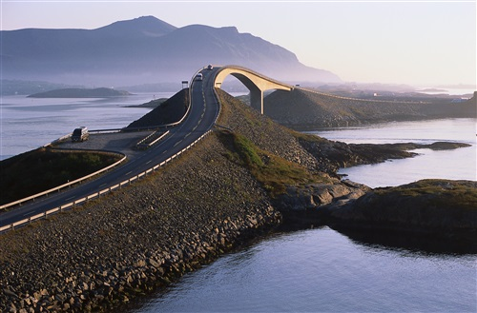  National Tourist Route – The Atlantic Road  A unique stretch of road which takes you right out to the ocean’s edge. In 2005, the road was voted Norway’s «Engineering Feat of the Century», and is also known to be the world's most beautiful drive. It connects Averøy with the mainland via a series of small islands and islets spanned by a total of eight bridges over 8274 meters.  http://www.nasjonaleturistveger.no/en/atlanterhavsvegen  Stop by Storseisundbrua – the tallest bridge on the road, with a beautiful, dramatic curve.  Stop at Bud and Ergan Coastal Fort  Fishing village Bud  In the 16th and 17th century Bud was the biggest trading post between Bergen and Trondheim. Today, Bud is still an active and charming fishing village with several good fish restaurants. Ergan coastal fort and information center.  http://www.visitmolde.com/en/Product/?TLp=32149&Ergan-Coastal-Fort=  http://www.visitmolde.com/en/Product/?TLp=377336  Departure from Bud  Arrival Molde.  The city's location and appearance, with lush gardens of roses and other flowers, combined with its breathtaking mountain panorama, has made Molde an attractive city to visit.  Visit to Varden viewpoint – The Molde Panorama  http://www.visitmolde.com/en/Product/?TLp=32322&Varden-the-Molde-Panorama=  Lunch at Molde Fjordstuer  http://www.classicnorway.no/hotell/hotell-molde-fjordstuer  Departure Molde  Ferry crossing Sølsnes – Åfarnes  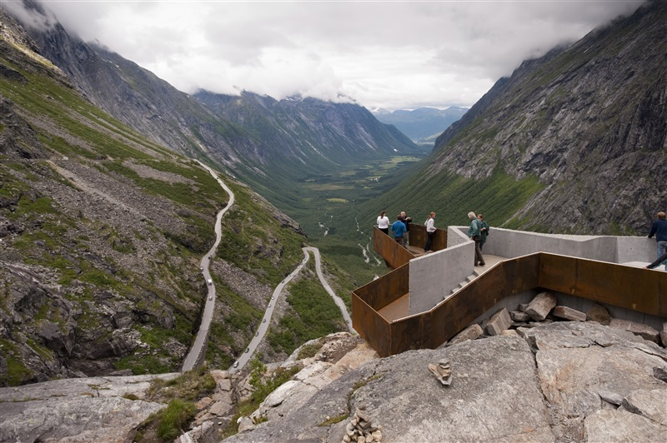  National Tourist Route – Geiranger-Trollstigen  Trollstigen - the "Troll Ladder" is a dramatic and exciting experience. The road twists through 11 hairpin bends as it climbs up to Stigrøra (858 metres above sea level). In some places it is cut into the mountain; in others it is built on top of stone walls. An impressive bridge in natural stone carries it across the Stigfossen waterfall.  www.visitandalsnes.com  http://www.nasjonaleturistveger.no/en/geiranger-trollstigen  Ferry crossing Linge – Eidsdal  Drive the Eagle’s Road – Ørnevegen to Geiranger  http://www.visitalesund-geiranger.com/en/Product/?TLp=381415  Photo stop at Ørnesvingen viewpoint  App arrival Geiranger. Check-in Hotel Union  Dinner in hotel restaurant  Hotel Union  6216 Geiranger  Tel +47 70 26 83 00 /email: geiranger@hotelunion.no  Web: www.hotelunion.no
22nd August Friday
09.30 -  11.00  11.15  12.00 | Boat trip on the Geirangerfjord with Geiranger Fjordsightseeing.  Walk the new Waterfall Path „Fossestien“, starting from Geiranger Fjord Centre.  www.verdsarvfjord.no  Drive to Westerås Farm  http://www.visitalesund-geiranger.com/en/Product/?TLp=381522&Westeras-Hytteutleige=  Lunch at Westerås Farm  Departure after lunch to Stryn.  National Tourist Route – Gamle Strynefjellsvegen  The over 100 years old road winds over the mountain between Stryn and Skjåk. For many years the gravel road was the only connection between east and west. To re-create the authentic feeling of driving on the road as it was in the old days the Norwegian Public Roads Administration has re-erected the row of guard stones.  http://www.nasjonaleturistveger.no/en/gamle-strynefjellsvegen  Driving time app 3,5hrs.  We stop at the Flydalsjuvet gorge for an impressive view over the Geirangerfjord.  http://www.visitalesund-geiranger.com/en/Product/?TLp=381416  Nibbevegen to Dalsnibba Viewpoint:  «Quite possibly the world’s finest view – 1500 m above sea level.»  Nibbevegen takes you from Djupvasshytta at 1039 m above sea level, to the viewpoint at Dalsnibba which is at approx 1500 m asl. You will have an unforgettable experience of fjord culture, views out towards the snow-covered mountains, pure air and the World Heritage Area - all at the same time.  Nibbevegen, a pioneer project and the very symbol of tourism in Geiranger, was opened in 1939. The fantastic panorama from the highest point includes fjords, peaks and high mountain terrain and is a ’must-see’ on any visit to the Geiranger area.  http://www.visitalesund-geiranger.com/en/Product/?TLp=381439  Dinner and overnight at Visnes Hotel in Stryn,  Visnes Hotel  Prestestegen 1, 6783 Stryn  Tel: +47 57 87 10 87 / email: booking@visnes.no  http://www.nordfjord.no/en/ACCOMMODATION/Hotel/?TLp=193730&Visnes-Hotel-Stryn=
23rd August Saturday
Morning  09.30  10.15  11.30  App 18 | Bus to Loen / Sande  Biking along Lovatnet Lake to Sande for those who wish (app 5km) : http://www.nordfjord.no/en/Product/?TLp=416448  Departure boat MS Kjenndal from Sande, a boat cruise on the beautiful Lovatnet Lake to Kjenndalen.  There are few boat-trips that are more beautiful than the trip on Loenvatnet Lake in Lodal Valley, encircled by high mountains and glacier tongues of Jostedalsbreen.  The boat trip is a spectacular experience . The trip passes the famous Mt. Ramnefjell, and Utigardsfossen Waterfall which is ranked 11 in the list of the ”Worlds most Famous Waterfalls”. The waterfall is especially spectacular when the water levels in the lake are high.  http://www.nordfjord.no/en/Product/?TLp=337227&MS-Kjendal-II-cruise-on-Lovatnet-Lake  Arrival Kjenndalen, the bus will take you further into the valley to the Kjenndalen Glacier. Light walk from the bus to the glacier.  http://www.nordfjord.no/en/Product/?TLp=227556&Kjenndal-Glacier  Bus back to Kjenndalsstova for lunch  Lunch at Kjenndalsstova Restaurant  http://kjenndalstova.no/  After lunch: Departure for Ålesund.  We drive via the scenic Norangsdalen Valley  Norangsdalen is one of the narrowest valleys in Norway, rich in both spectaculare sceneries as well as cultural memories. The valley bears the scars of the battle against the forces of nature. At lake Jelskred, the bottom of the valley is full of scree. At Urasætra and Stavbergsætra, the houses were built into the ground as protection against landslides. The lake known as Lygnstøylvatnet was formed by a rock fall from Keipen in 1908. Beneath the waters of the lake, you can still see remains of the old road, the foundations of the farmhouses and the gateway  http://www.visitalesund-geiranger.com/en/Product/?TLp=33855  Arrival Ålesund  THE ART NOUVEAU TOWN OF ÅLESUND  The Art Nouveau town of Ålesund could be taken right out of a fairy tale. If you look up as you explore the town, you will discover an abundance of imaginative ornamentation on the fronts of the buildings. Walk up the 418 steps to the top of Mount Aksla and you will be rewarded by unforgettable panoramic views!  www.visitalesund-geiranger.com  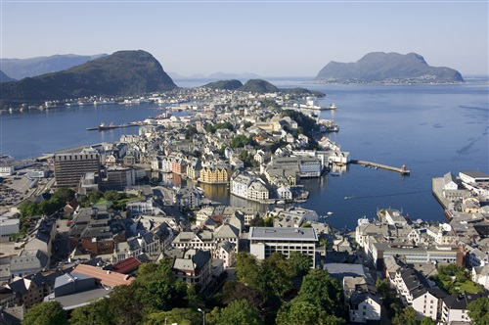  Dinner at a local restaurant in Ålesund.  Overnight in  Radisson Blu Hotel Ålesund  Sorenskriver Bullsgt. 7  Tel: Phone +47 70 160000 / email: sales.alesund@radissonblu.com  Web: http://www.radissonblu.com/hotel-alesund
24th August Sunday
Sightseeing Ålesund (depending on departure flight)

- City walk and visit to Jugendstilsenteret – Art Noveau Centre
www.jugendstilsenteret.no
- Aksla Viewpoint
http://www.visitalesund-geiranger.com/en/Product/?TLp=33378

Afternoon departure from Ålesund
IMPORTANT:
If you are delayed for a meeting, please call the contact person/ hotel/destination as soon as possible so that they are not waiting for you.
You are responsible for mini bar bills, pay tv, etc.

CONTACT PERSONS
Julie Strandheim |  | Fjord Norge AS/Fjord Norway  julie@fjordnorway.com | +47 90 80 27 90
Torunn Dyrkorn |  | Visit Kristiansund – Visit Molde  torunn@visitmolde.com
Beate Vik Hauge |  | Destinasjon Stryn & Nordfjord  beate@nordfjord.no
Bente Saxon |  | Visit Ålesund  Bente.saxon@visitalesund.com

