Welcome to Northern Norway!
www.northernnorway.com

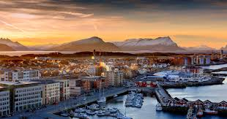 | 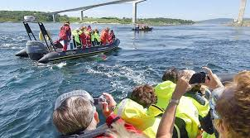 | 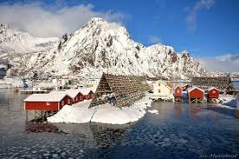
Photo: Visit Bodø | Visit Norway | Svinøya

Date: | 22-26 February 2018
Places you will visit: | Bodø og Lofoten

facebook.com/NorthernNorway | @northernnorway | northernnorway | @Northern_Norway

NB: accommodation, activities and meals in the program are paid by Northern Norway Tourist board. We kindly ask you to pay for all the extra services (telephone, mini-bar, room-service etc) that you might use during your trip. Thank you for understanding!

Date /Time: | Program:
21 February
 | Arrival
 | Check in at Scandic Havet www.scandichotels.no/hotell/norge/bodo/scandic-havet
22 February | Arrival
12:05 | Arrival
14:50 | Arrival
17:05 | Arrival
 | Visit Bodø meets you at the airport +47 93254586 www.visitbodo.no
 | Check in at Scandic Havet www.scandichotels.no/hotell/norge/bodo/scandic-havet
19:30 | Northern Light trip with Polar Tours including dinner www.polartours.no
23 February
 | Breakfast
10:00 | Visit the Norwegian Aviation Museum www.luftfartsmuseum.no
 | Try flying in a simulator https://www.newtonflightacademy.com/
13:00 | Lunch at Bjørk http://restaurantbjork.no/
14:00 | Craig Alibone http://craigalibone.com/
15:00 | Rib boat trip to Saltstraumen with Stella Polaris www.stella-polaris.no
18:00 | Light snack at Roast https://www.facebook.com/roastbodo/
19:00 | Northern light trip to Sandhornøya including dinner with Stella Polaris www.stella-polaris.no
 | Return to hotel
24 February
 | Breakfast and check out
07:00 | Buss to airprort
08:00 | Airplane to Leknes 08:00 – 08:25 www.wideroe.no
08:25 | Pick up at the airport by Arctic Buss Lofoten https://www.arcticbuss.no/nb/
 | Henrik from Destination Lofoten will meet you at the airport +47 90820310 www.lofoten.info
 | Trail trip Haukeland beach, with lots of photo opportunities
12:30 | Transport to Sørvågen - Smaken av Lofoten
14:00 | Lunch at Smaken av Lofoten http://smakenavlofoten.no/
15.00 | Check in at rorbuer http://smakenavlofoten.no/
16.00-18.30 | RIB safari to Moskenesstraumen with Smaken av Lofoten http://smakenavlofoten.no/
 | Time on your own
18.45-20.00 | Transport to Reine
19.00-20.45 | Dinner at Reine Rorbuer http://www.classicnorway.com/hotels/reine-rorbuer/restaurant-gammelbua/
20.45-21.00 | Transport back to and Smaken av Lofoten http://smakenavlofoten.no/
25 February
 | Breakfast and check out
08.30-10.00 | Transport to Lofotr Viking museum www.lofotr.no
10.00-12.30 | Guided tour and lunch at Lofotr Viking Museum www.lofotr.no
12.30-13.30 | Transport to Gimsøya
13.30-15.30 | Riding trip on Islandic horses at Gimsøya med Hov Hestegård www.hovhestegard.no
15:30- 16.30 | Transport to Henningsvær
16.45-17.55 | Time on your own or guided tour of Henningsvær
18.00-20.00 | Dinner and Stockfish history at Full Steam http://www.lofotenarctichotel.no/nb/aktiviteter/full-steam
20.00-22.30 | Guided Northern Light trip with Lofoten Aktiv http://www.lofoten-aktiv.no/en/
22.30 | Check in at Svinøya Rorbuer www.svinoya.no
26 February | Depart
 | Breakfast and check out
09.15-11.15 | Fish trip with XXLofoten on Simra including story telling.
11.30-12.20 | Lunch at Du Verden http://www.duverden.no/svolvar/
12.20-12.30 | Transport to Svolvær Airport
13:25 | Depart for Oslo via Bodø where you change plane WF801

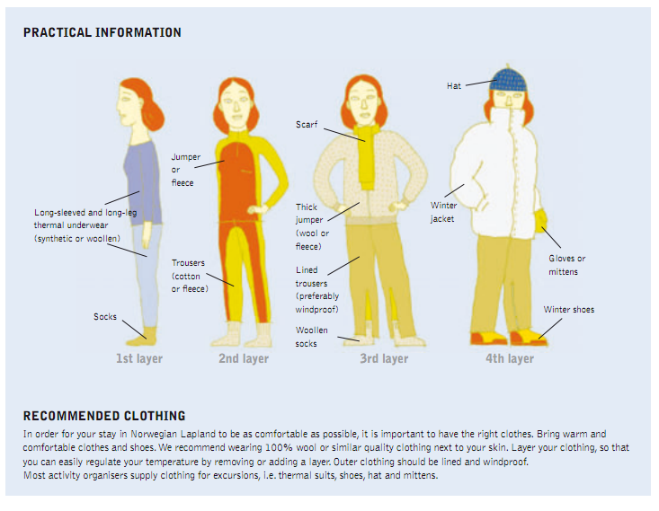

Clothing:
In order for your stay in Northern Norway to be as comfortable as possible, it is important to have the right clothes. Bring warm and comfortable clothes and shoes. We recommend wearing 100% wool or similar quality clothing next to your skin. Layer your clothing, so that you can easily regulate your temperature by removing or adding a layer. Outer clothing should be lined and windproof. Most activity organisers supply clothing for excursions, i.e. thermal suits, shoes, hat and mittens.

