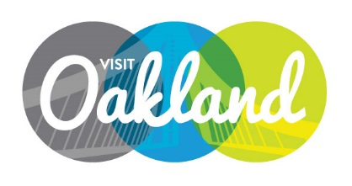

Board of DiRECTORS Meeting Agenda
Wednesday, March 11th – 4 pm
Location: Waterfront Hotel - Regatta II, 10 Washington St., Oakland
Mark Hochstatter, Chair, Presiding

- Call to Order M. Hochstatter

- Public Comment/Announcements

- Approval of Minutes Motion
- Minutes – Board of Directors January 13, 2015

- Staff Reports Staff
- Marketing
- PR & Community Relations
- Sales

- CEO Report A. Best
  - TID Update
  - Measure C Update
  - Convention Center Update
  - I AM Oakland
  - May 5th Tourism Breakfast
  - Restaurant Week Results
  - CEO Goals – Mid Year

- Approval of Financial Report M. Everton / Motion
- Adjournment M. Hochstatter

NEXT MEETING: Tuesday, May 12th – 4 pm Location TBD

Thank you Mark Everton and the Waterfront Hotel staff for hosting us today!

