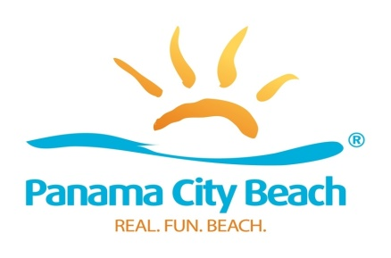
“Chasin’ The Sun” Television Show Wins Florida Tourism Marketing Award
PANAMA CITY BEACH, Fla., September 27, 2017 – “Chasin’ The Sun,” the original television series produced by Visit Panama City Beach, has been honored with a 2017 Flagler Award in recognition of outstanding achievement in Florida tourism marketing. The show received the bronze award in the Niche Marketing category during the annual Florida Governor’s Conference on Tourism in Hollywood, Florida last month.
“The Flagler Awards shine a spotlight on the best of the best in Florida tourism marketing and we’re pleased that ‘Chasin’ The Sun’ received this prestigious award,” says Visit Panama City Beach President and CEO Dan Rowe. “Throughout the state, tourism marketing organizations are producing excellent work and to be recognized for outstanding achievement by our industry peers is truly an honor.”
The Flagler Awards were established by VISIT FLORIDA in 2000 and are open to all individuals, private businesses and not-for-profit organizations offering a product or service that promotes tourism to or within the Sunshine State. For 2017, awards were presented to the top three entries in each of 17 categories.
“Chasin’ The Sun” premiered on Sportsman Channel with 13 original episodes in 2016 as a vehicle to showcase Panama City Beach’s diverse fisheries and to promote its reputation as an All-American, family vacation destination. Season two episodes aired on Destination America and NBC Sports Network.
In 2018, the show will air on Discovery Channel, which reaches nearly 100 million U.S. households and ended 2016 as cable’s #1 non-sports network among men for the second straight year, claiming nine of the top 10 unscripted series in the country.
The third season of “Chasin’ The Sun” will premiere in January 2018 in its regular time slot of Saturdays at 7:30 a.m.
Chasin’ the Sun website: www.ChasinTheSunTV.com
Twitter & Instagram: @ChasinTheSunTV
Facebook: www.facebook.com/ChasinTheSunFishingShow
Youtube: https://www.youtube.com/channel/UC8_MVhtonlafVMvveKUPZtg

About Panama City Beach
Panama City Beach is situated on 27 miles of sugar-white sand beaches bordering clear, turquoise waters where the Gulf of Mexico and St. Andrews Bay converge. With 320 days of sunshine annually and attractions such as St. Andrews State Park and Pier Park, the region has long been favored by travelers seeking an affordable beach vacation with year-round offerings for families, couples, groups and adventure-seekers. These offerings include championship golf courses, spas, sporting events, award-winning dining and diverse recreational activities. In addition, Panama City Beach’s Northwest Florida Beaches International Airport offers nonstop flights on Delta Airlines, Southwest Airlines and United Airlines. For more information, call 850-233-5070 or go to visitpanamacitybeach.com, the official website of the Panama City Beach Convention and Visitors Bureau. Live HD video of the world-famous beach is now available at visitpanamacitybeach.com/webcam. Stay connected with Panama City Beach on Twitter (@Visit_PCB) and Facebook (facebook.com/visitpanamacitybeach).
Media Contacts:
Charlotte Park / Michael Hicks Catie Feeney / J. Michael Brown
Lou Hammond Group Panama City Beach Convention & Visitors Bureau
843-371-1362 / 561-655-3836 850-233-5070
charlottep@louhammond.com cfeeney@visitpanamacitybeach.com
michaelh@louhammond.com jmbrown@visitpanamacitybeach.com

