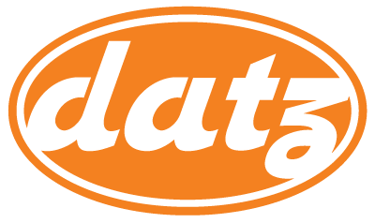

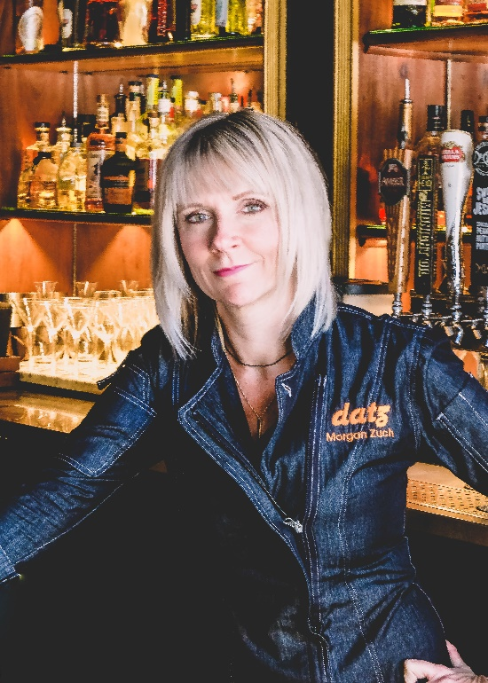
About Morgan Zuch:
Like a well-balanced cocktail, Morgan Zuch is equal parts cocktail consultant, spirits lover and manager. And in her current role as Beverage Director of Datz Restaurant Group, her profile is evolving far beyond the bar. A Level One Cicerone and WSET Sommelier, her drive for learning and experimenting with flavors has led to several accolades, including national finalist for Veev’s “A Better Way to Drink” Challenge; invitations to the prestigious Camp Runamok; and two-time winner of Creative Loafing’s Margarita Wars. Still, this USBG member and ambassador is most comfortable behind the bar, revving up cocktail menus to reflect seasonal trends and creative riffs on classic cocktails.
About Datz:
Datz is fun, flavorful American comfort food and cocktails with a flair. Datz is where Tampa’s carnivorous, chocolate-loving, bacon-hoarding omnivores gather for cocktails and conversation. Led by a team of shamelessly unapologetic flavor crusaders since 2009, Datz’s revolving door of invention and reinvention is unique, different and always effervescent. You can catch Datz and the mac & cheese stuffed meatloaf on recurring episodes of Travel Channel’s “Meatloaf Paradise” and Good Morning America.

