Board of Directors Nomination 2015-2016

Industry Category: Vancouver Convention Hotels
Term: Effective June, 2015; Two Years

Nominee: Marion Harper Treskin
General Manager
The Westin Bayshore, Vancouver

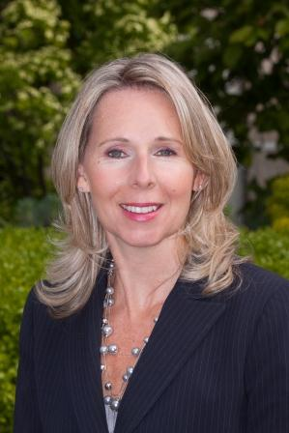

Marion is the General Manager of The Westin Bayshore, Vancouver. She has been in hospitality industry since 1985 working with Canadian Pacific Hotels & Resorts, Delta Hotels & Resorts, O’Neill Hotels and Resorts, The Westin Grand, Vancouver and The Westin Resort & Spa in Whistler and Starwood Hotels and Resorts. Prior to assuming the position of general manager at The Westin Bayshore, Vancouver in 2011 she was the General Manager of The Westin Grand.

Marion’s experience includes a number of hotel openings. Her hotel career began in Food and Beverage and she has held director roles in Rooms Division, Revenue Management & Reservations, Sales and Marketing at both a property level and in a regional capacity before becoming a General Manager in 2004.

Marion is active in the hotel community. She has been part of the Vancouver Hotel Destination Association (DMF) since its inception and still sits on the board. She is also the incoming Chair for the Hotel Association of Vancouver,

Marion was born in Toronto, Ontario but has made the West coast her home since 1990. She graduated from Centennial College in Toronto after completed a three year Hospitality and Tourism Administration program, majoring in Restaurants and Hotels.

